

Trucking Sample Business Plan

How to Use this Sample Business Plan
This sample business plan is based on a fictitious business. Every business is unique, and your business plan should reflect that.

Use this sample business plan as inspiration and when you’re ready to create your own pitch, plan, and financials - consider a tool like LivePlan.

With expert guidance, prompts, and automatic financials - save time and ensure your plan will impress lenders or investors. As a bonus for downloading this sample plan, click here to get 50% of LivePlan today.

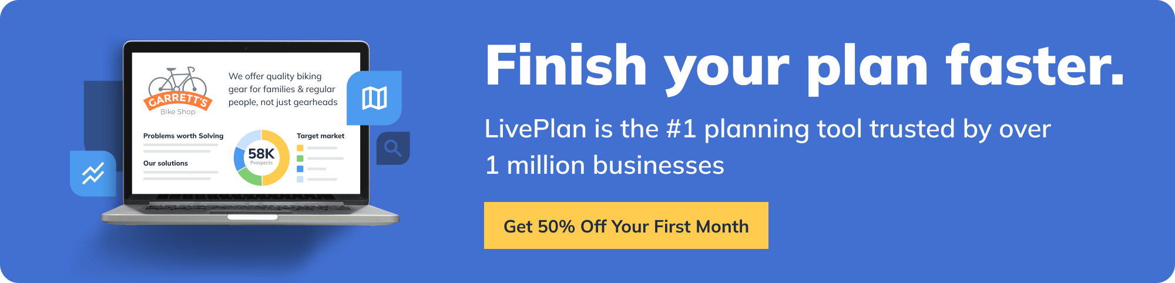

Value Proposition

ReliableRoadways offers efficient, reliable, and cost-effective freight transportation services across regional and national routes. Our fleet of state-of-the-art trucks and professional drivers ensure the timely delivery of goods, fostering trust and satisfaction among our clients.

The Problem

Businesses often grapple with finding dependable freight services that guarantee on-time delivery and proper handling of goods. They need a service that values their time and investment and offers real-time tracking of their shipments.

The Solution

ReliableRoadways offers a solution with our top-notch fleet, professional drivers, and real-time tracking system. Our commitment to upholding the highest standards in freight transportation ensures that goods are transported safely and arrive on time.

Target Market

Our primary market includes small to medium-sized businesses that require regular freight services for their operations. The secondary market comprises larger corporations seeking a reliable partner for their bulk transportation needs.

Competitors & Differentiation

Current Alternatives

- National freight companies
- Independent truck owner-operators
- Regional freight transportation services

Why Us?

ReliableRoadways stands out through our commitment to exceptional customer service, real-time shipment tracking, and guaranteed on-time delivery. Our comprehensive safety protocols and modern, well-maintained fleet minimize the risk of damage or delays, securing the trust and satisfaction of our clients.

Funding Needs

We seek an initial investment of $500,000 to acquire additional trucks, invest in advanced tracking technology, and cover operating costs, including insurance, maintenance, and salaries.

Sales Channels

- ReliableRoadways website
- Direct sales
- Industry trade shows
- Third-party logistics companies

Marketing Activities

- Online advertising and SEO
- Social media campaigns
- Networking at industry events
- Referral programs

Financial Projections

⭐️ Pro tip: You can certainly crunch these numbers yourself in spreadsheets but LivePlan makes calculating your numbers much easier with automatic financials, charts, and graphs.

Revenue

2023: $600,000
2024: $750,000
2025: $950,000

Expenses/Costs

2023: $450,000
2024: $525,000
2025: $600,000

Profit

2023: $150,000
2024: $225,000
2025: $350,000

Milestones

- Secure initial funding - July 1, 2023
- Purchase additional trucks - August 1, 2023
- Launch real-time tracking system - October 1, 2023
- Reach 100 consistent clients - March 1, 2024
- Expand routes nationally - January 1, 2025

Team and Key Roles

CEO

Overseeing overall operations, finance, and strategic direction.

Operations Manager

Managing daily operations, routing, and scheduling.

Fleet Maintenance Supervisor

Ensuring the proper functioning and safety of the fleet.

Sales & Marketing Manager

Driving business growth and brand visibility.

Partnerships & Resources

Truck Manufacturers
For purchasing and maintaining our modern fleet.

Tech Companies
For implementing advanced tracking and logistics software.

Freight Brokers
To secure regular contracts and expand our client base.

