[](https://www.bplans.com/?utm_source=bplans.com&utm_medium=download&utm_campaign=sample_plans&utm_content=airbnb_business_plan_docx_inline)

**Wedding Venue Sample Business Plan**

**How to Use this Sample Business Plan**

This sample business plan is based on a fictitious business. Every business is unique, and your business plan should reflect that.

Use this sample business plan as inspiration and when you’re ready to create your own pitch, plan, and financials - consider a tool like [LivePlan](https://www.liveplan.com/?offer=BUS_SAMPLE_HALFOFF&utm_source=bplans.com&utm_medium=download&utm_campaign=sample_plans&utm_content=wedding_venue_business_plan_docx_inline).

With expert guidance, prompts, and automatic financials - save time and ensure your plan will impress lenders or investors. As a bonus for downloading this sample plan, [click here to get 50% of LivePlan today](https://www.liveplan.com/?offer=BUS_SAMPLE_HALFOFF&utm_source=bplans.com&utm_medium=download&utm_campaign=sample_plans&utm_content=wedding_venue_business_plan_docx_inline).

[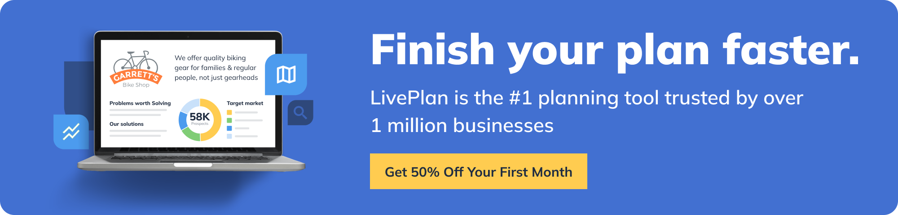](https://www.liveplan.com/?offer=BUS_SAMPLE_HALFOFF&utm_source=bplans.com&utm_medium=download&utm_campaign=sample_plans&utm_content=wedding_venue_business_plan_docx_ad1)

## 

## **Value Proposition**

Wedding Venue Bliss provides a stunning, customizable event space that couples can tailor to their dream wedding experience. Featuring picturesque outdoor settings and stylish indoor facilities, the venue offers a flexible, all-in-one location for ceremonies, receptions, and overnight accommodations.

### **The Problem**

Many wedding venues lack the versatility and resources to accommodate diverse wedding themes and personal touches. Couples often struggle to find a venue that offers both a beautiful environment and the necessary amenities for a seamless, memorable event.

### **The Solution**

Wedding Venue Bliss addresses these challenges by offering a customizable space that caters to various wedding themes and preferences. With indoor and outdoor options, on-site accommodations, and personalized services, couples can create the perfect setting for their big day.

### **Target Market**

The primary market for Wedding Venue Bliss is engaged couples seeking a unique and adaptable location for their wedding ceremony and reception. The secondary market includes event planners, corporate clients, and families organizing special events and celebrations.

## **Competitors & Differentiation**

### **Current Alternatives**

* Traditional wedding venues (e.g., hotels, banquet halls)
* Country clubs and golf courses
* Parks and gardens
* Vineyards and wineries
* Historic sites and landmarks

### **Why Us?**

Wedding Venue Bliss stands out with its customizable event spaces and a comprehensive range of services, ensuring a stress-free and memorable experience. Our team of professionals offers personalized assistance in event planning, catering, and design, allowing couples to bring their vision to life.

### **Funding Needs**

The target property costs $600,000. The property will be purchased with a 20% down payment plus closing costs. $50,000 in renovations and upgrades are required. The estimated funding needed for furniture, event equipment, initial supplies, and a contingency fund is $50,000. The total initial funding needed is $230,000.

### **Sales Channels**

* Wedding Venue Bliss Website
* Wedding Planner Associations
* Social Media Platforms
* Local Tourism Boards
* Wedding and Event Websites

### **Marketing Activities**

* Social Media Campaigns
* Blogging and Content Marketing
* Collaborations with Local Wedding Vendors
* Press Releases and Media Outreach
* Bridal Expos and Trade Shows

### **Financial Projections**

**⭐️ Pro tip:** You can certainly crunch these numbers yourself in spreadsheets but [LivePlan](https://www.liveplan.com/?offer=BUS_SAMPLE_HALFOFF&utm_source=bplans.com&utm_medium=download&utm_campaign=sample_plans&utm_content=wedding_venue_business_plan_docx_inline) makes calculating your numbers much easier with automatic financials, charts, and graphs.

### **Revenue**

2023: $120,000

2024: $150,000

2025: $180,000

### **Expenses/Costs**

2023: $80,000

2024: $90,000

2025: $100,000

### **Profit**

2023: $40,000

2024: $60,000

2025: $80,000

### **Milestones**

* Obtain necessary permits and licenses — June 1, 2023
* Complete renovations and upgrades — August 1, 2023
* Set up event spaces and accommodations — September 1, 2023
* Launch website and social media accounts — September 15, 2023
* Open for business — October 1, 2023
* Host first wedding event — December 1, 2023
* Partner with local wedding vendors — January 1, 2024
* Achieve 70% or higher booking rate — June-September, 2024
* Expand event offerings and services — January 1, 2025

## **Team and Key Roles**

### **Owner/Operator**

Responsible for overseeing the daily operations of Wedding Venue Bliss, including event coordination, guest accommodations, and community engagement.

### **Event Manager**

Manages the coordination and execution of events, working closely with clients and vendors to ensure a seamless and memorable experience.

### **Housekeeping and Maintenance Staff**

Ensure the cleanliness and upkeep of event spaces, accommodations, and common areas, as well as maintaining the venue's facilities and equipment.

## **Partnerships & Resources**

The purpose of these partnerships is to provide clients with a comprehensive range of services and resources to create a seamless and memorable wedding experience while supporting local businesses and fostering collaboration within the community.

### **Local Wedding Vendors**

Partner with photographers, florists, caterers, and entertainers to offer clients a one-stop solution for their wedding needs, ensuring seamless coordination and high-quality services.

### **Bridal Boutiques and Tuxedo Rentals**

Collaborate on promotional offers, cross-promotion of products and services, and referrals to offer clients a complete wedding package.

### **Local Hotels and Accommodations**

Establish relationships with nearby hotels and accommodation providers to offer overflow lodging options for wedding guests and secure special rates for clients.

### **Wedding Planners and Event Coordinators**

Develop partnerships with local wedding planners and event coordinators to increase referrals, collaborate on marketing efforts, and streamline the planning process for clients.

### **Community Organizations and Nonprofits**

Engage with community organizations and nonprofits to host charity events, fundraisers, and awareness campaigns, positioning Wedding Venue Bliss as a community-conscious business.