

Accounting and Bookkeeping Business Plan Template

How to Use This Template

Edit this Google Doc version directly to fit your needs. **This copy is yours.**

This template is a simplified business plan outline. It’s a good way to get started, but as you know, you can’t just type in your details, print it, and turn it in to the bank. Every business is unique, and your business plan should reflect that. Use this template as the starting point to [write your business plan](https://www.liveplan.com/blog/how-to-write-a-business-plan-step-by-step-free-templates/) and customize it to reflect your unique business.

What makes this template unique?

* **Pro tips** **(noted in green)** are based on our experience helping over a million business owners write their business plans. Consider these tips as you create your own plan.
* Writing your business plan is just one step in achieving your broader business goal. At the end of this template, you’ll find **next steps to help you achieve your goal *faster***.
* Because you downloaded this business plan template—you get access to an [**exclusive offer for 50% off your first month of LivePlan**](https://www.liveplan.com/pricing?&offer=BUS_SAMPLE_HALFOFF&utm_source=Liveplan&utm_medium=Download&utm_campaign=Sample_plan&utm_content=accounting_and_bookkeeping), the #1 rated business plan builder, which can be found throughout this template.

[](https://www.liveplan.com/pricing/?offer=BUS_SAMPLE_HALFOFF&utm_source=Liveplan&utm_medium=Download&utm_campaign=Sample_plan&utm_content=accounting_and_bookkeeping)

**Confidential**

The Sorcerer's Accountant

Business Plan

Prepared [date]

**Contact Information**

Jane Smith

jane@yourcompany.com

111.222.333

yourcompany.com

1234 Main St.  
Anywhere, OR 12345

Table of contents

1.0 **Executive Summary** **1**

Chart: Highlights 2

1.1 Objectives 2

1.2 Mission 2

1.3 Keys to Success **2**

**2.0 Company Summary** **3**

2.1 Company Ownership 3

2.2 Company History 3

Table: Past Performance 4

Chart: Past Performance4

**3.0 Services**  **7**

**4.0 Market Analysis Summary** **9**

4.1 Market Segmentation 9

Table: Market Analysis 10

Chart: Market Analysis (Pie) 11

4.2 Target Market Segment Strategy 11

4.3 Service Business Analysis 11

4.3.1 Competition and Buying Patterns 12

**5.0 Web Plan Summary**  **13**

5.1 Website Marketing Strategy 13

5.2 Development Requirements 13

**6.0 Strategy and Implementation Summary** **14**

6.1 Competitive Edge 14

6.2 Marketing Strategy 14

6.3 Sales Strategy 15

6.3.1 Sales Forecast 15

Table: Sales Forecast 17

Chart: Sales Monthly 18

Chart: Sales by Year 18

6.4 Milestones 19

Table: Milestones 19

Chart: Milestones 20

**7.0 Management Summary** **21**

7.1 Personnel Plan 21

Table: Personnel 22

**8.0** **Financial Plan** **23**

8.1 Important Assumptions 23

8.2 Break-even Analysis 23

Table: Break-even Analysis 24

Chart: Break-even Analysis 24

8.3 Projected Profit and Loss 25

Table: Profit and Loss 25

Chart: Profit Monthly 27

Chart: Profit Yearly 27

Chart: Gross Margin Monthly 28

Chart: Gross Margin Yearly 28

8.4 Projected Cash Flow 28

Table: Cash Flow 29

Chart: Cash 30

8.5 Projected Balance Sheet 31

[8.6 Business Ratios](https://docs.google.com/document/d/1SnpfiDlAK1408IFS3ZO1APYGXwFN1C0Q/edit#heading=h.cxnr8k2rrhyk) 32

Table: Ratios 32

**Appendix**

Table: Sales Forecast 36

Table: Personnel 37

Table: Profit and Loss 38

Table: Cash Flow 39

Table: Balance Sheet 40

# Executive Summary

**⭐️ Pro tip:** We typically recommend you revisit this section after you’ve finished the rest of your business plan so that you can easily summarize what you’ve already written.

The Sorcerer's Accountant is a small, successful, one-person accounting and tax preparation service owned and run by Max Greenwood, CPA in Chicago, Illinois. The firm offers tax accounting, management accounting, and QuickBooks set-up and training for small business clients. To move beyond a one person model, the business will expand its services to include bookkeeping services for small businesses. This will require an investment in marketing and staff to grow the business to include this complementary line of business. This business plan organizes the strategy and tactics for the business expansion and set objectives for growth over the next three years.

The business will offer clients bookkeeping services with the oversight of a CPA at a price they can afford. To do this involves hiring undergraduate student bookkeepers and a graduate student manager, keeping fixed costs as low as possible, and continuing to define the expertise of Sorcerer's Accounting through its website resources. The effect will be sales more than doubling over three years as 8 part-time bookkeepers are deployed to client businesses as needed, and salary and dividends to Greenwood increase substantially.

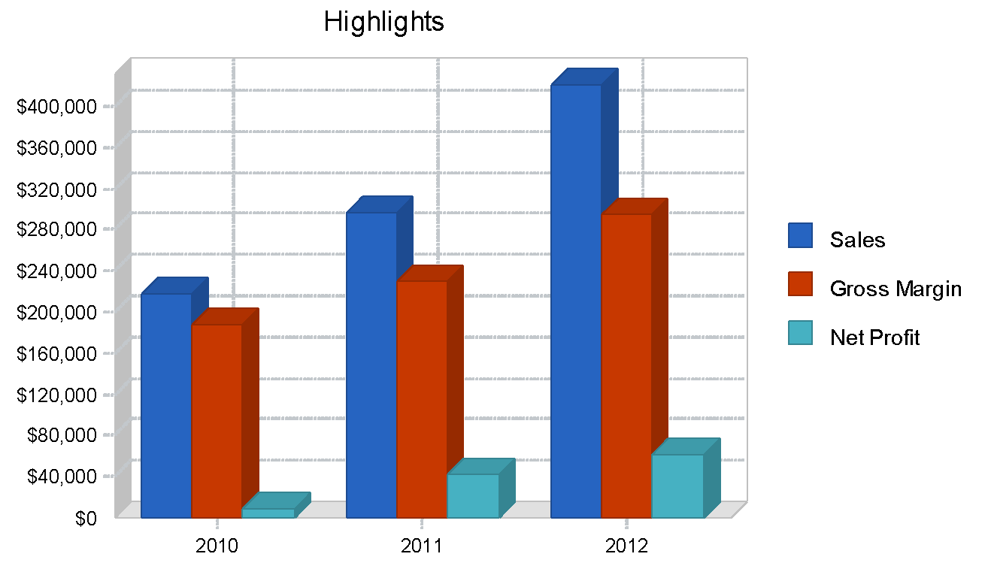

### Objectives

The Sorcerer's Accountant seeks to launch a new line of services - small business bookkeeping - which will be offered to the same ongoing clients as Sorcerer's Accounting currently seeks.

Sorcerer's Accounting has set the following objectives:

* To launch the bookkeeping services slowly, beginning with two part-time bookkeepers
* To achieve bookkeeping service annual revenues equal or greater to the current total revenues within three years (effectively doubling revenue)
* To achieve net profit of $60,000 in three years
* To employ 8 part-time bookkeepers in three years

### Mission

The Sorcerer's Accountant seeks to provide a full suite of tax and management accounting services for small businesses in Chicago, Illinois, allowing business owners to not only save money over in-house accounting and ensure their compliance with tax laws, but to make valuable management decisions from their numbers.

### Keys to Success

The keys to success for the accounting business include:

* Building trust with clients
* Maintaining up-to-date CPA certification and education on accounting practices and laws
* Going beyond saving clients money to proposing how they can increase their revenues
* Legal and ethical practices when it comes to transparency, reporting, and taxes

[](https://www.liveplan.com/pricing/?offer=BUS_SAMPLE_HALFOFF&utm_source=Liveplan&utm_medium=Download&utm_campaign=Sample_plan&utm_content=accounting_and_bookkeeping)

# Company Summary

**⭐ Pro tip:** Stuck staring at a blank page? Overcome writer's block with [LivePlan Assistant's Help Me Write feature.](https://www.liveplan.com/features/ai-powered-liveplan-assistant/?offer=BUS_SAMPLE_HALFOFF&utm_source=Liveplan&utm_medium=Download&utm_campaign=Sample_plan&utm_content=accounting_and_bookkeeping) Simply input your ideas (or start from scratch) and let AI help transform them into professional business plan content that you can then customize to match your vision.

The Sorcerer's Accountant, established in 2020 by Max Greenwood, is a one-person CPA firm which provides tax services, management and cost consulting services, and QuickBooks sales and added services. Sorcerer's Accounting serves small businesses (under $5 million in revenue) in the Chicago, IL area, primarily in service industries. The Sorcerer's Accountant plans to add bookkeeping services to its suite of services to better serve its current and future clients.

### Company Ownership

Max Greenwood is founder and 100% owner of The Sorcerer's Accountant, a sole proprietorship.

### Company History

Founded with $10,000 of start-up capital by Max Greenwood, CPA in 2020, The Sorcerer's Accountant has become a full-time endeavor for Greenwood. At first focused entirely on tax services, Greenwood added management and cost accounting services in 2021 and then QuickBooks reselling and services to small businesses and startups in 2022, after becoming a certified QuickBooks Pro Advisor. This has allowed Sorcerer's Accounting to provide a wide range of services to small businesses over its lifetime from launch through expansion and growth.

The Sorcerer's Accountant has grown significantly in past years to $175,000 in total annual revenue, but has had difficulty taking on additional work due to the limits on Greenwood's time. Client retention has been a positive factor, with 75% of 2023 clients repeating service in 2023.

The business operates out of a small rented office which has enough room for one additional employee. The office is not used for client meetings - they are held entirely at client offices.

### Past Performance

|  | **FY2021** | **FY2022** | **FY2023** |
| --- | --- | --- | --- |
| **Past Performance** |  |  |  |
| Sales | $100,000 | $150,000 | $175,000 |
| Gross Margin | $75,000 | $112,500 | $131,250 |
| Gross Margin % | 75.00% | 75.00% | 75.00% |
| Operating Expenses | $55,000 | $67,500 | $82,750 |
| Collection Period (days) | 30 | 25 | 28 |
|  |  |  |  |
| Balance Sheet |  |  |  |
|  | 2021 | 2022 | 2023 |
|  |  |  |  |
| Current Assets |  |  |  |
| Cash | $15,000 | $17,500 | $20,000 |
| Accounts Receivable | $4,167 | $6,250 | $7,292 |
| Other Current Assets | $5,000 | $5,000 | $5,000 |
| **Total Current Assets** | $24,167 | $28,750 | $32,292 |
|  |  |  |  |
| Long-term Assets |  |  |  |
| Long-term Assets | $0 | $0 | $0 |
| Accumulated Depreciation | $0 | $0 | $0 |
| **Total Long-term Assets** | $0 | $0 | $0 |
|  |  |  |  |
| **Total Assets** | $24,167 | $28,750 | $32,292 |
|  |  |  |  |
| Current Liabilities |  |  |  |
| Accounts Payable | $4,583 | $5,625 | $6,896 |
| Current Borrowing | $0 | $0 | $0 |
| Other Current Liabilities (interest free) | $0 | $0 | $0 |
| **Total Current Liabilities** | $4,583 | $5,625 | $6,896 |
|  |  |  |  |
| Long-term Liabilities | $0 | $0 | $0 |
| **Total Liabilities** | $4,583 | $5,625 | $6,896 |
|  |  |  |  |
| Paid-in Capital | $10,000 | $10,000 | $10,000 |
| Retained Earnings | -$10,417 | -$51,875 | -$83,554 |
| Earnings | $20,000 | $65,000 | $98,950 |
| **Total Capital** | $19,583 | $23,125 | $25,396 |
|  |  |  |  |
| **Total Capital and Liabilities** | $24,167 | $28,750 | $32,292 |
|  |  |  |  |
| Other Inputs |  |  |  |
| Payment Days | 30 | 30 | 30 |
| Sales on Credit | $50,000 | $75,000 | $87,500 |
| **Receivables Turnover** | 12.00 | 12.00 | 12.00 |

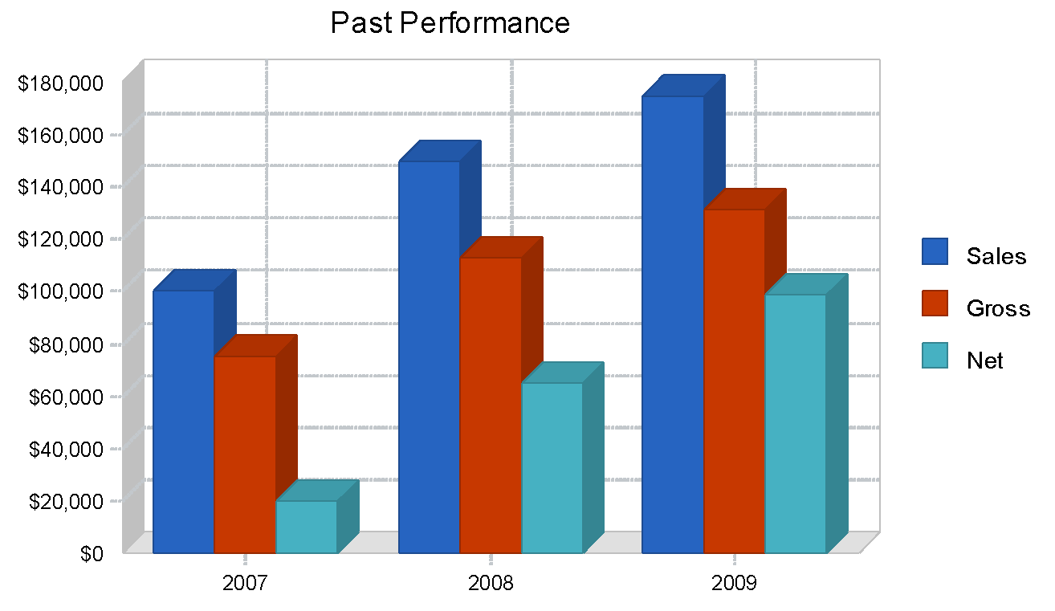

[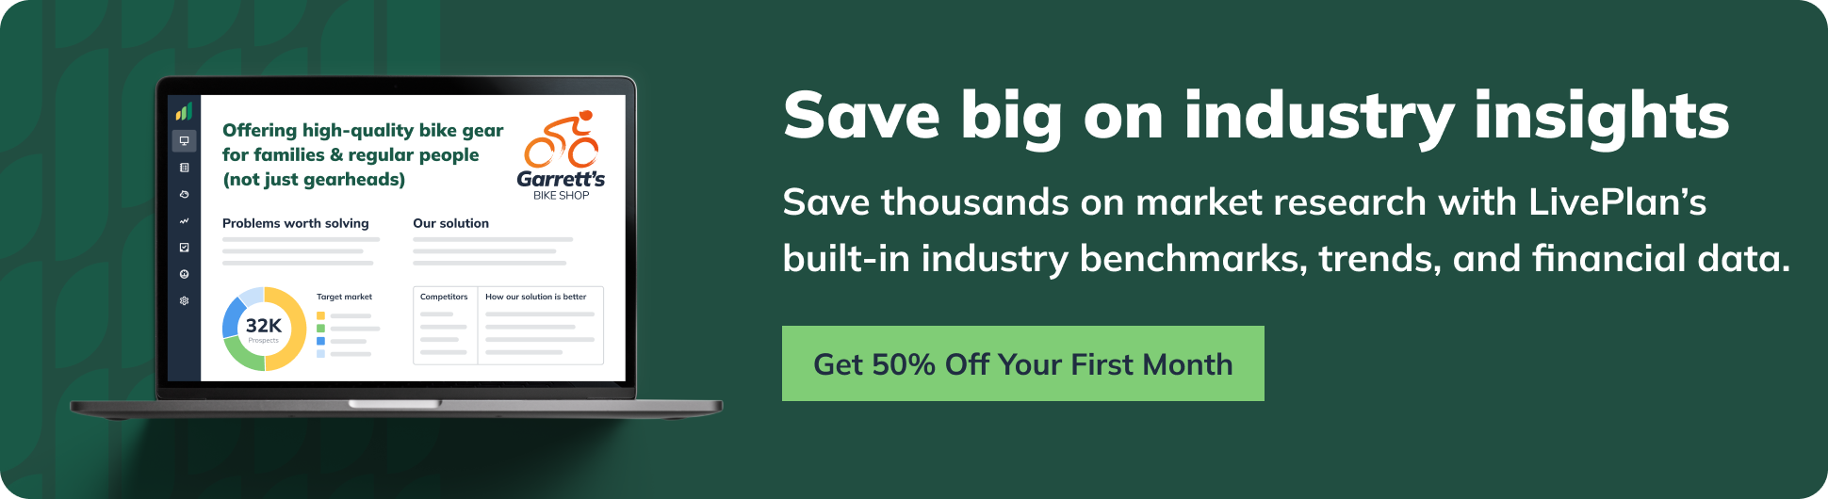](https://www.liveplan.com/pricing?offer=BUS_SAMPLE_HALFOFF&utm_source=Liveplan&utm_medium=Download&utm_campaign=Sample_plan&utm_content=accounting_and_bookkeeping)

# 

# Services

**⭐️ Pro tip:** Using the power of AI, [LivePlan Assistant’s Rewrite](https://www.liveplan.com/features/ai-powered-liveplan-assistant?offer=BUS_SAMPLE_HALFOFF&utm_source=Liveplan&utm_medium=Download&utm_campaign=Sample_plan&utm_content=accounting_and_bookkeeping) feature will **instantly help add additional details** to each of these sections when prompted.

Current services offered by The Sorcerer's Accountant include:

### Tax Services:

* Tax preparation
* Tax planning
* Addressing tax problems (audit representation, back taxes owed, payroll tax problems, IRS issues, bankruptcy)

### Management/Cost Accounting Services:

* Audits
* Cost and Margin Analysis
* Financial Projection
* Setup for credit card processing

### QuickBooks Services

* QuickBooks sales and setup
* QuickBooks training
* QuickBooks tips (via website)
* QuickBooks "quicktune" service (audit and fix of QuickBooks files)

Current services are either provided entirely by Max Greenwood or available through resources on the The Sorcerer's Accountant website. Greenwood will provide referrals to credit card processing companies or some speciality consultants when the need calls for it, but focuses his work on general small business services of use to the widest variety of businesses.

The Sorcerer's Accountant intends to add the following **bookkeeping services:**

* Payroll processing
* Accounts payable (entry, bill paying)
* Accounts receivable (entry, invoicing, deposits, collection)
* Sales tax processing
* Bank reconciliations
* Inventory management
* Financial statement preparation
* Other financial reporting

These bookkeeping services will be at a rate of $30 per hour/per bookkeeper for clients. Clients would pay $20 -$25, once benefits and taxes are factored in, for an in-house, part-time bookkeeper, and would still be responsible for training, oversight, and management in that case. The Sorcerer's Accountant's rate is very economical once this is taken into account.

The new services will be performed by part-time student bookkeepers who are current undergraduate accounting majors with up to 20 hours per week free to work. Each business will have a consistent bookkeeper assigned to it. The bookkeepers will be trained by Max Greenwood directly in proper techniques. They will all be students in the top 20% of their class with at least one professional recommendation and one educational (professor) recommendation. This is a business model which has been successful in other cities where there is ample student labor, such as New York City.

To add additional value, the bookkeeping manager, a graduate student pursuing an MBA in accounting, will supervise and audit the work of the bookkeepers, answering their questions when questions arise, and providing quality assurance. The bookkeeping manager will review the QuickBooks files and reports created by the bookkeepers to ensure that they follow proper formats and are prepared correctly.

[](https://www.liveplan.com/pricing/?offer=BUS_SAMPLE_HALFOFF&utm_source=Liveplan&utm_medium=Download&utm_campaign=Sample_plan&utm_content=accounting_and_bookkeeping)

# Market Analysis Summary

⭐**Pro tip:** Enhance your competitive analysis by using [LivePlan's industry benchmarks](https://www.liveplan.com/features/industry-statistics?offer=BUS_SAMPLE_HALFOFF&utm_source=Liveplan&utm_medium=Download&utm_campaign=Sample_plan&utm_content=accounting_and_bookkeeping) to identify where your business can outperform market averages.

The small business accounting market consists of virtually every small business in the United States. As businesses grow larger than one person sole proprietorships, they generally require expert help with at least their tax preparation, and often with additional bookkeeping and accounting services. Even many non-employer sole proprietorships will use accounting help at some point. While some small businesses hire bookkeepers or CFOs directly, many successfully outsource these types of services.

The accounting service market as a whole includes the following:

* Corporate accounting and auditing firms: The "Big Four" (PricewaterhouseCoopers, Ernst & Young, Deloitte Touche Tohmatsu, and KPMG) and their competitors
* Small business accounting
* Personal accounting (by H & R Block and the like)

The National Society of Accountants states that it represents more than 30,000 independent practitioners who provide services to 19 million individuals and businesses. The continuing evolution of U.S. tax laws guarantees work for tax accountants on an ongoing basis. The market is somewhat recession-proof, as businesses which are contracting use accountants to help cut spending and limit tax liability just as growing businesses will use accountants to launch and prepare financials for expansion, mergers and acquisitions.

### Market Segmentation

The market of small businesses in Chicago for The Sorcerer's Accountant represents approximately 85,000 businesses in 2024. It has been divided into three groups:

**Non-employer firms:** Without employees, these firms do not have many of the concerns of larger businesses. However, the owners must be vigilant to protect their own tax liability and sort out how their personal and business tax returns intersect. These firms are generally buyers of QuickBooks services and tax preparation services. As they grow, this group becomes ripe for outsourced bookkeeping services before they can hire an full-time in-house bookkeeper.

**Very small businesses:** Made up of businesses that are designed to stay small and those which are growing through a phase, these businesses require payroll services, bookkeeping, and tax preparation. They are concerned about losing control, but can generally be convinced of using outsourced accounting and bookkeeping with cost analysis. With the stakes higher, these businesses can make greater use of management accounting services, especially as most cannot afford a dedicated CFO. Many do not need a full-time bookkeeper, but can make do with part-time help, which limits their hiring options.

**Other small businesses:** Many of these businesses will have some in-house financial management and bookkeeping help. However, they may be able to save money by outsourcing these services, as they are not generally core to what the business seeks to do. These businesses may be comfortable with their situation as a cash producer for their owners or intent on growing or positioning themselves for sale.

|  |  |  |  |  |  |  |  |
| --- | --- | --- | --- | --- | --- | --- | --- |
| **Market Analysis** |  |  |  |  |  |  |  |
|  |  | 2024 | 2025 | 2026 | 2027 | 2028 |  |
| Potential Customers | Growth |  |  |  |  |  | CAGR |
| Non-employer Firms | 4% | $50,000 | $52,000 | 54,080 | 56,243 | $58,493 | 4.00% |
| Very Small Businesses (2 to 10 employees) | 4.00% | 25,000 | 26,000 | 27,040 | 28,122 | 29,247 | 4.00% |
| Other Small Businesses (11 to 99 employees) | 4% | $10,000 | $10,400 | 10,816 | 11,249 | $11,699 | 4.00% |
| **Total** | 4.00% | 85,000 | 88,400 | 91,936 | 95,614 | $99,439 | 4.00% |

## 

### Target Market Segment Strategy

The Sorcerer's Accountant will focus on the "very small business" target group for its bookkeeping services as this group can make the most consistent use of part-time bookkeepers. The type of student bookkeepers whom these businesses would hire are generally students of the same kind. However, these businesses often do not have the resources to provide proper oversight or training to their bookkeepers, and will suffer from not having the leverage to hire the cream of the crop. The Sorcerer's Accountant can provide the solution to these problems.

### Service Business Analysis

The small business accounting industry consists of numerous independent accountants and bookkeepers as well as many small firms. Larger firms tend to pursue medium and large business clients.

Accounting and bookkeeping services are purchased by owners and top managers of small businesses. They will contact businesses by phone and generally meet in person (at the client's office) to interview and discuss the prospect of working together.

### Competition and Buying Patterns

Major competitors in the Chicago market include:

* **Corporate Bookkeeping Services:** Provides general bookkeeping services, not taxes. Seeks entrepreneurial clients specifically, especially in the real estate industry. The business has only been in existence for a few years and has no CPA leadership.
* **MasterType Accounting Business Services,** P.C.: Accounting and bookkeeping services, including a bookkeeping software package. Their major weakness is the reliance on their own software package rather than QuickBooks, the industry standard for small businesses.

For bookkeeping services, the business also must compete indirectly against the prospect of businesses hiring their own part-time bookkeepers. This gives businesses the advantage of greater control and perhaps development of a future full-time employee. If the hire works out, the cost can be lower for a business than an outside service. However, this can lead to employees who are not as well-educated or experienced as bookkeepers through a bookkeeping service who have worked with a range of businesses. Generally, the cost is lower in the long run with a bookkeeping service, as training is done more systematically and supervisors are more regimented and experienced.

To choose between competitors, factors considered by clients include:

* Positive references (especially from known sources or other businesses in the same industry)
* CPA leadership (protects the businesses, even if work is being performed by non-CPAs)
* Price (often low on the list of considerations, as long as price is not exorbitantly high)

## 

# Web Plan Summary

The website for The Sorcerer's Accountant presents a simple, uncluttered look which holds a great deal of information about services offered beneath its surface and beyond its homepage. The purpose of the website is to assure clients and potential clients of the expertise of the company and then inspire them to call for a phone or in-person consultation.

To redevelop the website for the new bookkeeping services to be offered, additional service pages will be created for each subset of the bookkeeping service as well as a main page presenting the value proposition and benefits to clients of the services. All areas will offer descriptions to be clear about what services are and are not offered, but will be focused on client benefits.

### Website Marketing Strategy

To market the website, many of the current tactics will be maintained, but supplemented.

* Expanding Google Adwords with $1,000 per month devoted to bookkeeping-related keywords for the Chicago market
* Listing the website on databases and other websites for small business services and bookkeeping services in Chicago
* Promoting the service to small business blogs and posting to blogs directly wherever possible
* Referencing the website in print ads and the brochure

Most of these marketing activities will be executed by the marketing services firm contracted by Sorcerer's Accounting as Greenwood does not have the time or expertise to execute them  himself.

The website will be expanded with additional information about best practices of bookkeeping services. Max Greenwood will devote 40 hours to developing this content within two months of the launch of the service.

### Development Requirements

The website redevelopment will require the marketing service partner for the business to create new pages based on the template already set by the existing website. All copy will be written by Max Greenwood. Graphics and design elements will be added by the marketing partner. There is not a need for e-commerce, a back-end, or other functionality for the website.

# Strategy and Implementation Summary

To promote the business to its target of businesses with 2 to 10 employees, The Sorcerer's Accountant will:

* Expand its Web presence through website development and marketing
* Initiate a systematic client referral program to prospect within existing clients and their contacts
* Use print ads in local business publications to target small business readers

### Competitive Edge

The Sorcerer's Accountant will achieve a competitive edge among Chicago bookkeeping services due to its combination of CPA oversight with lower-level, inexpensive labor. Clients will receive the advantage of having a CPA review their books and propose additional advice when appropriate, while not paying much more than they would to hire their own part-time bookkeeper.

This is not an inimitable competitive edge, but the market in Chicago is large enough to allow for the success of Sorcerer's Accounting with this strategy. Large firms ignore the small business market because they are better positioned to serve larger businesses. They are unlikely to imitate this strategy as they will find it difficult to convince small businesses that they can offer services which are affordable to them.

### Marketing Strategy

The Sorcerer's Accountant will use the following marketing tactics to reach its target market of very small businesses (2 to 10 employees) with its new bookkeeping services:

* Website marketing (detailed in the Web plan section)
* Redevelopment of the The Sorcerer's Accountant brochure with an additional section about the services
* Periodic advertisements in Chicago small business publications, each tracked to determine whether they yield inquiries and clients

The marketing messages will focus on the economics of the decision to use outsourced bookkeepers from The Sorcerer's Accountant and the advantage of CPA oversight with Greenwood's experience and track record.

Marketing also encompasses the search for student bookkeepers. Job listings will be posted at local universities and promote the learning involved in the position and the "leg up" it can give students for accounting positions upon graduation. We will recruit the best student bookkeepers possible. The costs associated with this hiring are only the time of Max Greenwood.

### Sales Strategy

The sales strategy for The Sorcerer's Accountant's new bookkeeping services is to attempt to sell the service predominantly to existing clients, especially at first before marketing pays off with new inquiries. This will require Max Greenwood to inform all existing clients by phone about the idea, once he has determined that they are qualified to use the service. Whenever possible, clients will be approached during regularly scheduled calls and meetings so as to not require a great deal of additional prospecting time.

Greenwood will then ask clients directly for referrals to other businesses and business owners they know who may be right for the bookkeeping services. Greenwood will seek to contact two referrals per day. When and if existing clients and referrals are exhausted, Greenwood will engage in cold calling to likely prospects he has heard about from other businesses.

The result of this initiative of direct selling is expected to be at least five clients within the first couple of months, as many current Sorcerer's Accounting clients appear extremely ready for this service and trusting of Max Greenwood.

### Sales Forecast

⭐ **Pro tip:** Uncertain about your financial projections? [LivePlan's experts](https://www.liveplan.com/features/live-guidance?offer=BUS_SAMPLE_HALFOFF&utm_source=Liveplan&utm_medium=Download&utm_campaign=Sample_plan&utm_content=accounting_and_bookkeeping) can help you create realistic forecasts during a live consultation session.

Unit prices represent the average project cost for tax services ($750), cost accounting projects ($1,000), and QuickBooks services ($300). Bookkeeping services are set at $30 per hour. Direct unit costs are very low for all of these services as they are primarily labor services. Tax projects incur a 5% cost for printing and travel, cost accounting projects incur 3% cost, primarily for travel. QuickBooks services are generally given remotely and sales of QuickBooks are done directly to the vendor (Greenwood Accounting receives a commission on software sold). Bookkeeping services incur a 50% cost of sales as the bookkeepers are paid at $15 per hour.

Total sales are expected to rise significantly with the success of the bookkeeping services revenue stream. The existing revenue streams are projected to grow at slow rates, as Max Greenwood cannot take on much additional work. They are not projected to grow at all in 2024, as Greenwood will spend additional time on the establishment of the bookkeeping services. Furthermore, these revenues will drop by 20% in the first quarter as additional time is spent by Greenwood on hiring, training and launching this revenue stream.

The sales forecast assumes part-time bookkeepers working 20 hours per week. These will grow from 2 bookkeepers working below capacity at the start of 2024 to 3 by the end of 2024, to 4 in 2025 and 8 by the end of 2026. Revenues will begin in the second month after training in the first month of 2024. This growth rate is made possible by the intention to do everything possible to retain clients and grow with them, as well as to actively seek referrals to other businesses from each client. Two levels of oversight (Greenwood's oversight over the Bookkeeping Manager, and the Bookkeeping Manager's oversight over all bookkeepers) will improve quality assurance and the chances of a high level of client retention and satisfaction.

Direct cost of sales are very low for the business as most costs are fixed. Travel to client sites, printing and paper, and other direct supplies for clients are the only direct costs for services provided directly by Greenwood. The direct labor of student bookkeepers for the bookkeeping services is $15 per hour, or 50%. Wages for non-billable hours (training periods) for new bookkeepers are listed in the Personnel table.

|  | **FY2024** | **FY2025** | **FY2026** |
| --- | --- | --- | --- |
| Sales Forecast |  |  |  |
| Unit Sales |  |  |  |
| Tax Preparations | 125 | $130 | $135 |
| Cost Accounting Analysis | 60 | 63 | 65 |
| QuickBooks Services | 57 | $59 | $62 |
| Bookkeeping Hours | 1,570 | 3,925 | 7,850 |
| **Total Unit Sales** | 1,812 | 4,177 | 8,112 |
|  |  |  |  |
| Unit Prices | 2024 | 2025 | 2026 |
| Tax Preparations | $750.00 | $750.00 | $750.00 |
| Cost Accounting Analysis | $1,000.00 | $1,000.00 | $1,000.00 |
| QuickBooks Services | $300 | $300 | $300 |
| Bookkeeping Hours | $30 | $30 | $30 |
|  |  |  |  |
| Sales |  |  |  |
| Tax Preparations | $93,600 | $97,500 | $101,250 |
| Cost Accounting Analysis | $60,300 | $63,000 | $65,000 |
| QuickBooks Services | $17,100 | $17,700 | $18,600 |
| Bookkeeping Hours | $47,100 | $117,750 | $235,500 |
| **Total Sales** | $218,100 | $295,950 | $420,350 |
|  |  |  |  |
| Direct Unit Costs | 2024 | 2025 | 2026 |
| Tax Preparations | $37.50 | $37.50 | $37.50 |
| Cost Accounting Analysis | $30.00 | $30.00 | $30.00 |
| QuickBooks Services | $0 | $0 | $0 |
| Bookkeeping Hours | $15 | $15 | $15 |
|  |  |  |  |
| Direct Cost of Sales |  |  |  |
| Tax Preparations | $4,680 | $4,875 | $5,063 |
| Cost Accounting Analysis | $1,809 | $1,890 | $1,950 |
| QuickBooks Services | $0 | $0 | $0 |
| Bookkeeping Hours | $23,550 | $58,875 | $117,750 |
| **Subtotal Direct Cost of Sales** | $30,039 | $65,640 | $124,763 |

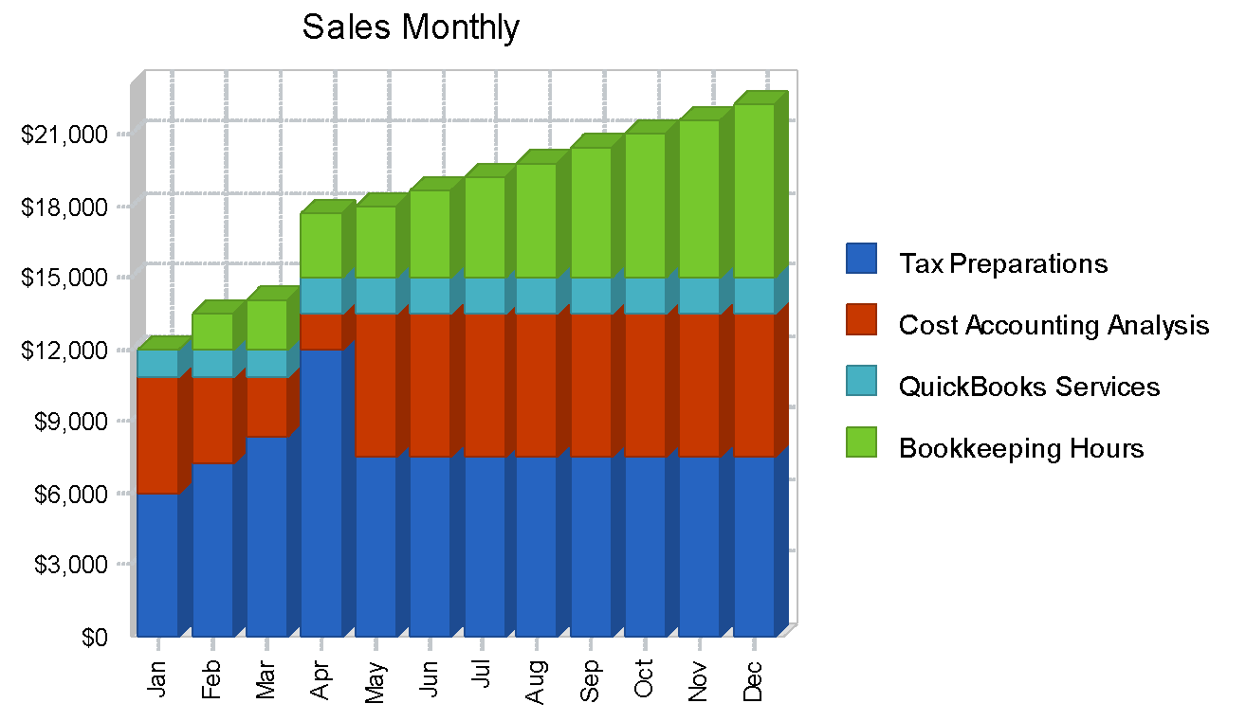

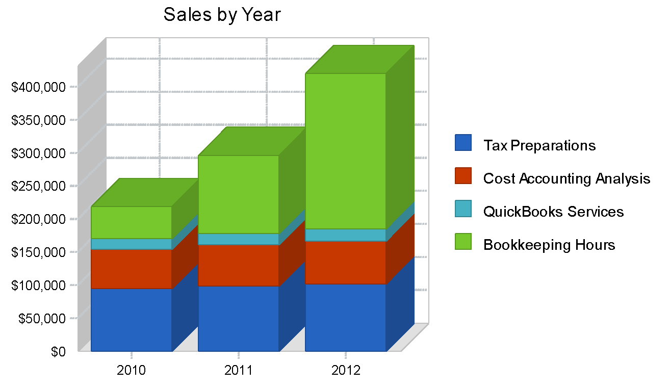

### Milestones

**⭐️Pro tip:** Not sure what milestones to track? Our [video guide](https://www.liveplan.com/blog/planning/milestones-as-business-roadmap?offer=BUS_SAMPLE_HALFOFF&utm_source=Liveplan&utm_medium=Download&utm_campaign=Sample_plan&utm_content=accounting_and_bookkeeping) shows you which ones matter most.

To execute the milestones listed, Max Greenwood will make liberal use of an outside marketing service firm (OF denotes outside firm on the table) which will manage the execution of the marketing activities listed. Greenwood will directly execute the sales activities listed through his work with clients.

$4,000 of these costs will be incurred at the end of 2023 and are included in operating costs on the past performance table.

|  |  |  |  |  |  |  |
| --- | --- | --- | --- | --- | --- | --- |
| Milestones |  |  |  |  |  | Milestones |
| Milestone | Start Date | End Date | Budget | Manager | Department | Milestone |
| Redevelop Website | 12/1/2023 | 1/1/2024 | $2,500 | MG (OF) | Marketing | Redevelop Website |
| List Website on Databases | 1/1/2024 | 1/15/2024 | $500 | MG (OF) | Marketing | List Website on Databases |
| Change Yellow Pages ads | 1/1/2024 | 1/15/2024 | 500 | MG (OF) | Marketing | Change Yellow Pages ads |
| Search Engine Marketing | 1/1/2024 | 12/31/2024 | $12,000 | MG (OF) | Marketing | Search Engine Marketing |
| Expand Website Best Practices Section | 12/1/2023 | 2/28/2024 | 0 | MG | Marketing | Expand Website Best Practices Section |
| Redevelop Brochure | 12/1/2023 | 1/1/2024 | 1,000 | MG (OF) | Marketing | Redevelop Brochure |
| Print New Brochures | 1/1/2024 | 1/15/2024 | $3,000 | MG (OF) | Marketing | Print New Brochures |
| Promotion to Clients | 1/1/2024 | 1/31/2024 | $0 | MG | Sales | Promotion to Clients |
| Promotion to Client Referrals | 2/1/2024 | 2/28/2024 | $0.00 | MG | Sales | Promotion to Client Referrals |
| Develop Print Ad | 12/1/2023 | 12/15/2023 | $500.00 | MG (OF) | Marketing | Develop Print Ad |
| Run first print ads | 2/1/2024 | 2/15/2024 | $5,000 | MG (OF) | Marketing | Run first print ads |

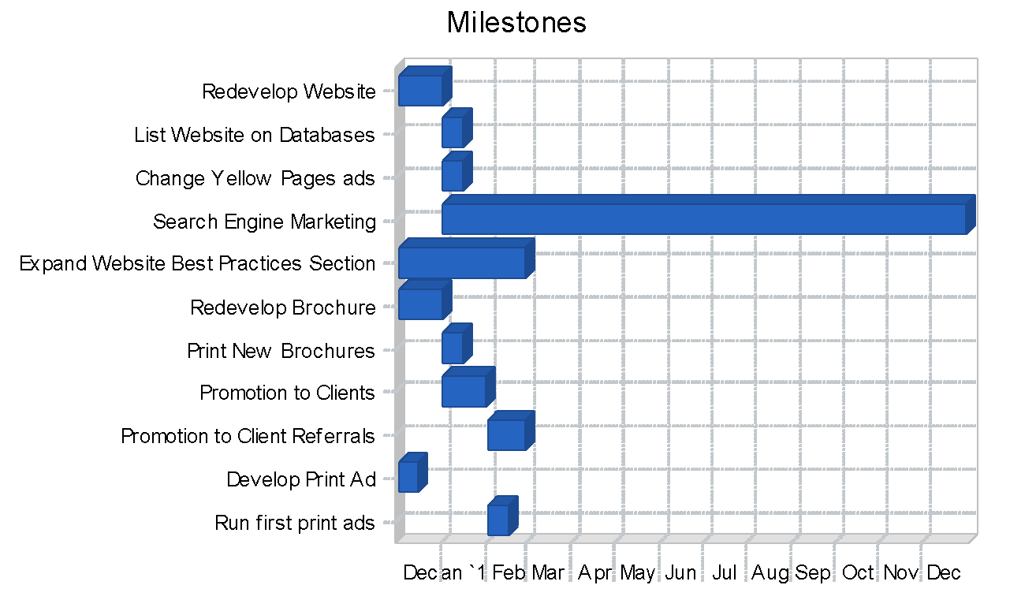

# Management Summary

Max Greenwood is CEO and sole manager of The Sorcerer's Accountant. With the launch of bookkeeping services, Greenwood will oversee a part-time bookkeeping manager who will oversee the work of the bookkeepers. The manager will be in an MBA or MS accounting program with professional work experience and bookkeeping experience, preferably at the start of his or her graduate school program so that he or she can work through the program's two years and then be considered for a move to a full-time position in year three. This manager will work from the Sorcerer's Accounting office or remotely, checking in with the bookkeepers by email and phone to remain apprised of the situations and problems they are facing. The manager will be present for the bookkeepers' training by Max Greenwood, so he or she will be aware of their responsibilities and requirements.

Periodically, the manager will visit the bookkeepers on-site and also request to audit their work directly to spot any problems before they become issues for the clients. Any issues with the bookkeepers will be reported by the clients to the bookkeeping manager directly. He will either handle them himself or report to Greenwood for help.

Greenwood will remain in close contact with the bookkeeping manager and review work samples from the bookkeepers at least once a month.

### Personnel Plan

The bookkeeping manager will move from a part-time position over the next two years to a full-time position in the third year. As mentioned previously, this is designed for an accounting graduate student interested in being part of this growing organization. If this student becomes a CPA, the role can continue to expand and he can take on accounting work within the organization as well as oversight of the student bookkeepers. This growth, and the fact that the business will offer benefits, are the strategy to retain this key employee in future years.

Direct cost wages for student bookkeepers' billable hours are listed in the Sales Forecast. The wages shown for student bookkeepers in this table represent only training periods (non-billable hours) when new bookkeepers join the business. We will start with two part-time bookkeepers at the start of 2024, and increase to three midyear, adding a fourth in the second year and doubling the student bookkeeping staff to eight total in the third year.

Employee benefits are 10% of payroll and are provided only for the management.

|  | **FY2024** | **FY2025** | **FY2026** |
| --- | --- | --- | --- |
| **Personnel Plan** |  |  |  |
|  | 2024 | 2025 | 2026 |
| Bookkeeper training-period wages | $1,200 | $400 | $1,600 |
| Max Greenwood | $60,000 | $65,000 | $70,000 |
| Bookkeeper Manager | $24,000 | $28,800 | 48,000 |
| Benefits | $8,400 | $9,380 | $11,800 |
| Total People | 5 | 6 | 10 |
|  |  |  |  |
| **Total Payroll** | $93,600 | $103,580 | $131,400 |

# 

# Financial Plan

**⭐ Pro tip:** Using the power of AI, [LivePlan Assistant](https://www.liveplan.com/features/ai-powered-liveplan-assistant?offer=BUS_SAMPLE_HALFOFF&utm_source=Liveplan&utm_medium=Download&utm_campaign=Sample_plan&utm_content=accounting_and_bookkeeping) can help you **generate predicted revenue streams** based on your business type so that you can instantly generate ideas for how you might drive or grow your revenue.

The financial plan of the business requires growth financed by positive cash flows from operations. Additional outside investment or owner investment is not necessary. The new business line is not capital-intensive, but will increase fixed costs of the business which must be covered almost immediately by additional revenues from bookkeeping sales. This is feasible because it is expected that at least five current clients will use the service without hesitation as they are ready to start using a bookkeeper or outsource their current bookkeeping.

### Important Assumptions

The business will grow the number of part-time bookkeepers with the business over these next three years. In the first year, two bookkeepers will work at less than 20 hours per week each for several months before reaching capacity, and a third bookkeeper will join us mid-year. A fourth part-time bookkeeper will be added in year two, and four more will be added in year three.

### Break-even Analysis

Our monthly revenue break-even is based on the fixed costs of running the current business along with the old lines of business. This is a significant increase from the 2023 break-even point. The increased marketing activity, capacity, payroll, benefits, and computer expenses for the new bookkeeper, insurance for the new line of business, and cost of sales to hire bookkeepers drives this break-even point higher.

|  | **FY2024** |
| --- | --- |
| **Break-even Analysis** |  |
|  |  |
| Monthly Units Break-even | 141 |
| Monthly Revenue Break-even | $16,926 |
|  |  |
| Assumptions: |  |
| Average Per-Unit Revenue | $120 |
| Average Per-Unit Variable Cost | $16.58 |
| **Estimated Monthly Fixed Cost** | **$14,595** |

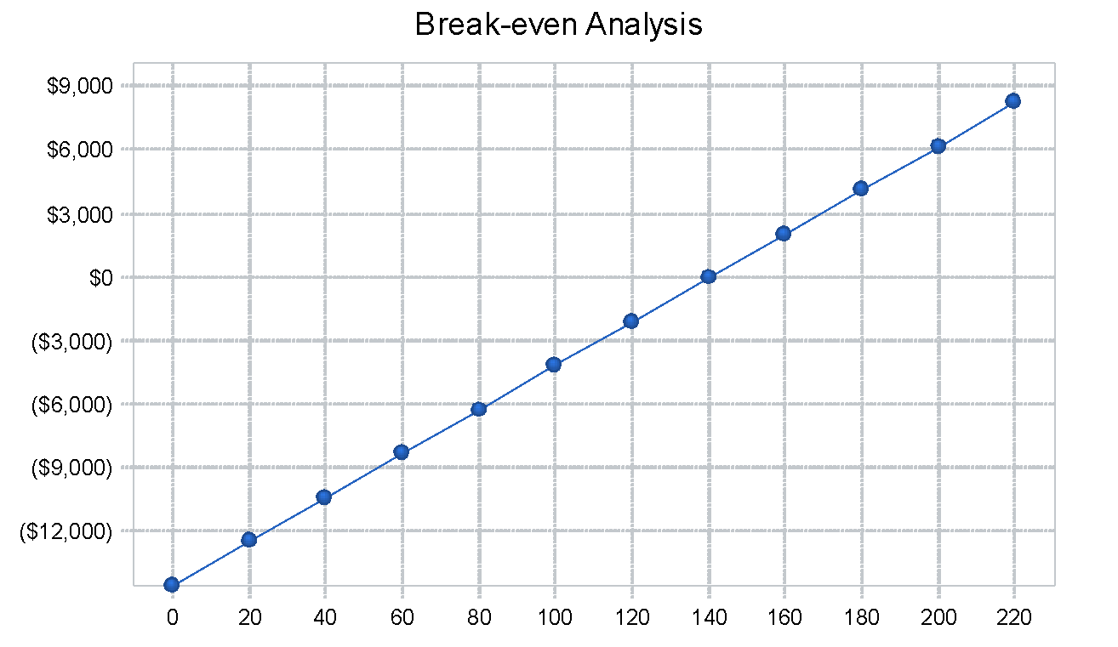

### Projected Profit and Loss

The Sorcerer's Accountant actually expects its gross margin to fall as it takes on bookkeepers to fulfill the new bookkeeping service. This will move from the firm's gross margin from being in line with a non-employer firm to a contractor firm that provides labor to businesses. The growth in revenues will offset this drop in gross margin and produce steady growth in net profit. Marketing will include the activities listed for 2024 in the milestones table as well as additional runs of print ads in local publications beyond the first few months. This expense will drop somewhat in future years as marketing returns to the business's focus on referrals and word-of-mouth from clients.

Rent and utilities will not grow significantly, as only Greenwood and the bookkeeping manager will work out of the office space. Insurance will grow to cover the added liability of additional employees working in client spaces. Payroll taxes are set at 15% of payroll and the bookkeeping labor items. Employee benefits are 10% of payroll and are provided only for the management. January will be a month of additional setup training to bring the new bookkeepers and manager online and install additional software and computers. Software and computer expenses to provide accounting software for the laptops of student bookkeepers and to continue to upgrade the systems of the business will grow. In the first year, this includes a computer and software set-up for the bookkeeping manager.

|  | **FY2024** | **FY2025** | **FY2026** |
| --- | --- | --- | --- |
| Pro Forma Profit and Loss |  |  |  |
|  | 2024 | 2025 | 2026 |
| Sales | $218,100 | $295,950 | $420,350 |
| Direct Cost of Sales | $30,039 | $65,640 | $124,763 |
| Other Cost of Sales | $0 | $0 | $0 |
| **Total Cost of Sales** | $30,039 | $65,640 | 124,763 |
|  |  |  |  |
| Gross Margin | $188,061.00 | $230,310 | 295,588 |
| Gross Margin % | 86.23% | 77.82% | 70.32% |
|  |  |  |  |
|  |  |  |  |
| Expenses |  |  |  |
| Payroll | $93,600 | $103,580 | $131,400.00 |
| Marketing/Promotion | $38,500 | $20,000 | $20,000 |
| Depreciation | $0 | $0 | $0 |
| Rent | $18,000 | $18,720 | $19,469 |
| Utilities | $2,400 | $2,496 | $2,596 |
| Insurance | $5,000 | $7,000 | $8,000 |
| Payroll Taxes | $14,040 | $15,537 | $19,710 |
| Software and Computer Expenses | $3,600 | $4,000 | $6,000 |
|  |  |  |  |
| Total Operating Expenses | $175,140 | $171,333 | $207,175 |
|  |  |  |  |
| Profit Before Interest and Taxes | $12,921 | $58,977 | $88,413 |
| EBITDA | $12,921.00 | $58,977.00 | $88,413.00 |
| Interest Expense | $0.00 | $0.00 | $0.00 |
| Taxes Incurred | $3,876 | $17,693 | $26,524 |
|  |  |  |  |
| Net Profit | $9,045 | $41,284 | $61,889 |
| **Net Profit/Sales** | 4.15% | 13.95% | 14.72% |

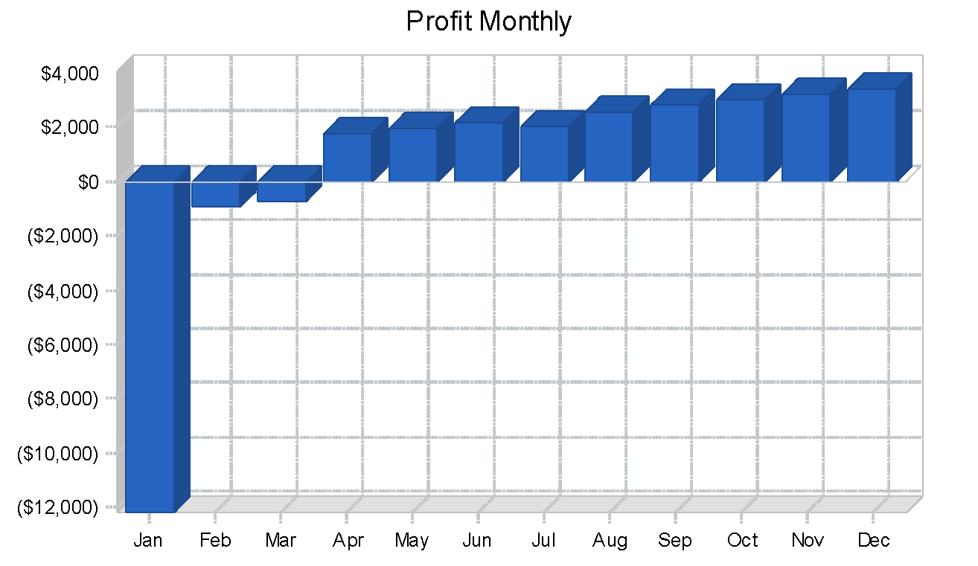

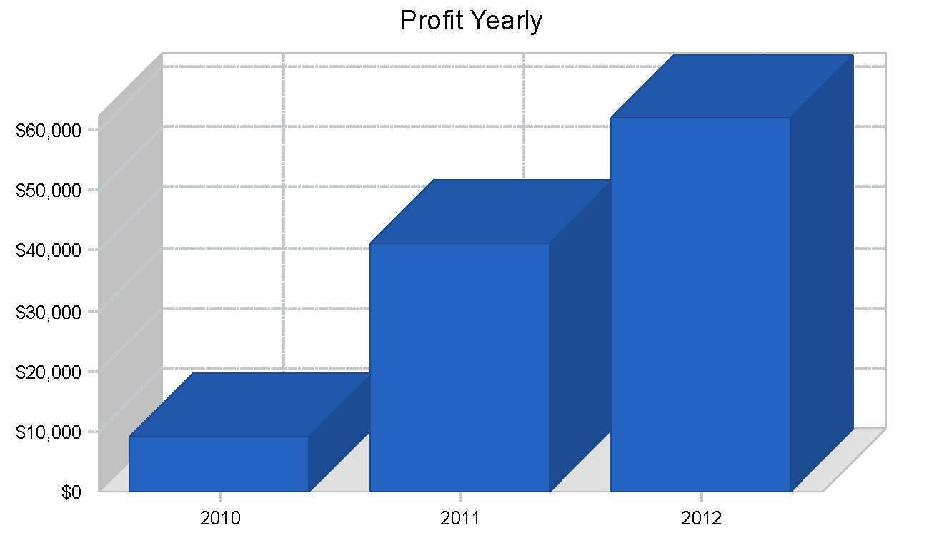

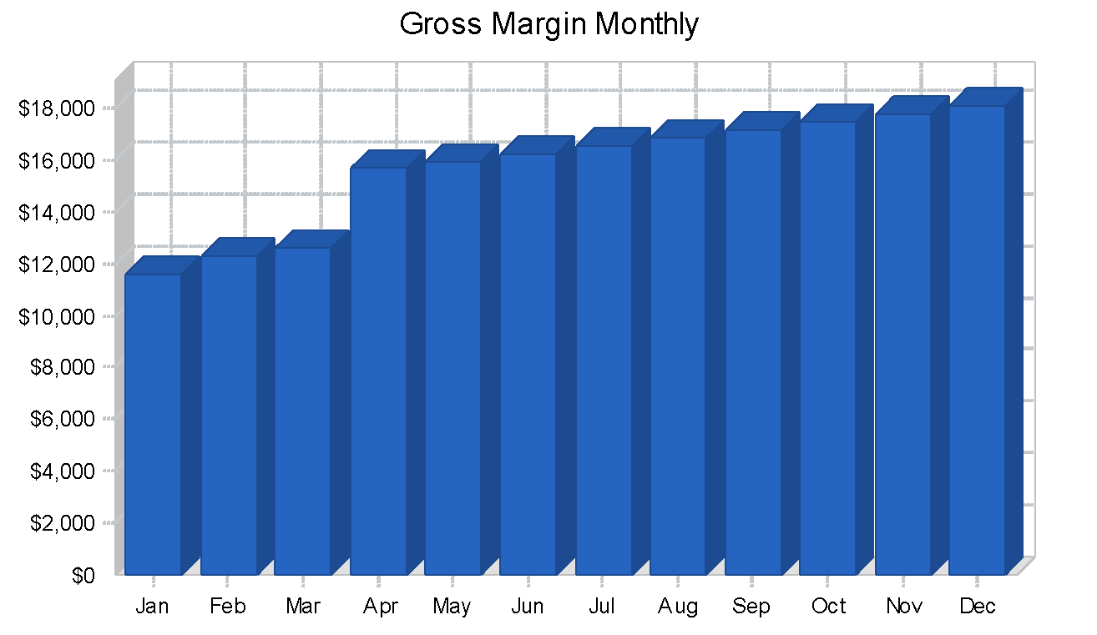

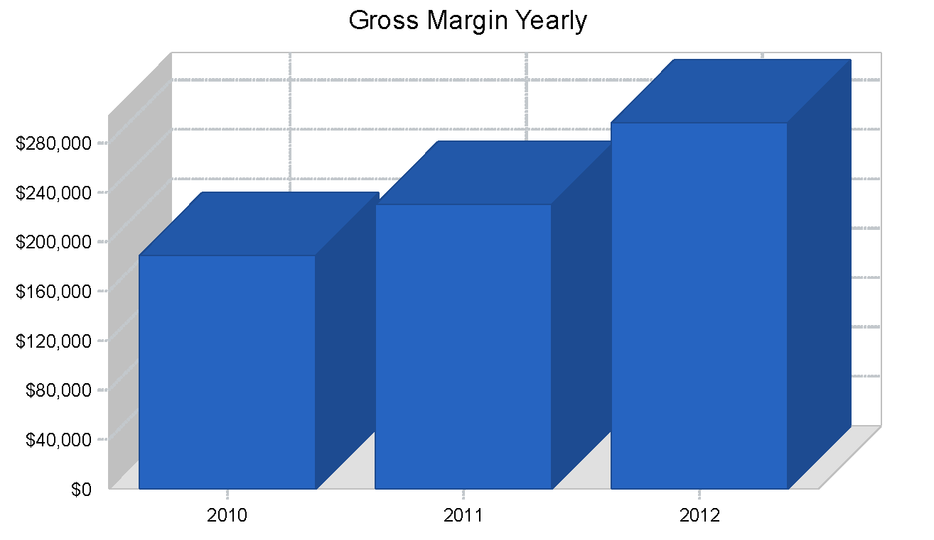

### Projected Cash Flow

The expansion of the business can be undertaken with the current cash reserves, even accounting for a cash loss over $10,000 in February, 2024 as the marketing and set-up expenses for the new business line must be paid. The business will return to positive cash-flow in the second quarter. The fact that the part-time bookkeepers will only be deployed on paying jobs lowers the risk of this new business line to the cost of the bookkeeping manager and marketing. Significant cash reserves can be built up in future years for an acquisition or additional service expansion or the owner can take dividends as shown.

|  | **FY2024** | **FY2025** | **FY2026** |
| --- | --- | --- | --- |
| Pro Forma Cash Flow |  |  |  |
|  | 2024 | 2025 | 2026 |
| Cash Received |  |  |  |
|  |  |  |  |
| Cash from Operations |  |  |  |
| Cash Sales | $109,050 | $147,975 | 210,175 |
| Cash from Receivables | $105,612 | $144,145 | $204,055 |
| **Subtotal Cash from Operations** | $214,662.00 | $292,120 | 414,230 |
|  |  |  |  |
| Additional Cash Received |  |  |  |
| Sales Tax, VAT, HST/GST Received | $0 | $0 | $0 |
| New Current Borrowing | $0 | $0 | $0.00 |
| New Other Liabilities (interest-free) | $0 | $0 | $0.00 |
| New Long-term Liabilities | $0 | $0 | $0 |
| Sales of Other Current Assets | $0 | $0 | $0 |
| Sales of Long-term Assets | $0 | $0 | $0 |
| New Investment Received | $0 | $0 | $0 |
| **Subtotal Cash Received** | $214,662 | $292,120 | $414,230 |
|  |  |  |  |
| Expenditures | 2024 | 2025 | 2024 |
|  |  |  |  |
| Expenditures from Operations |  |  |  |
| Cash Spending | $93,600 | $103,580 | $131,400 |
| Bill Payments | $111,643 | $149,376 | $220,816 |
| **Subtotal Spent on Operations** | $205,243.00 | $252,956.00 | $352,216.00 |
|  |  |  |  |
| Additional Cash Spent |  |  |  |
| Sales Tax, VAT, HST/GST Paid Out | $0 | $0 | $0 |
| Principal Repayment of Current Borrowing | $0 | $0 | $0 |
| Other Liabilities Principal Repayment | $0 | $0 | $0 |
| Long-term Liabilities Principal Repayment | $0 | $0 | $0 |
| Purchase Other Current Assets | $0 | $0 | $0 |
| Purchase Long-term Assets | $0 | $0 | $0 |
| Dividends | $0 | $20,000 | $60,000 |
| **Subtotal Cash Spent** | $205,243 | $272,956 | $412,216 |
|  |  |  |  |
| **Net Cash Flow** | $9,418 | $19,164 | $2,013 |
| **Cash Balance** | $29,418 | $48,582 | $50,596 |

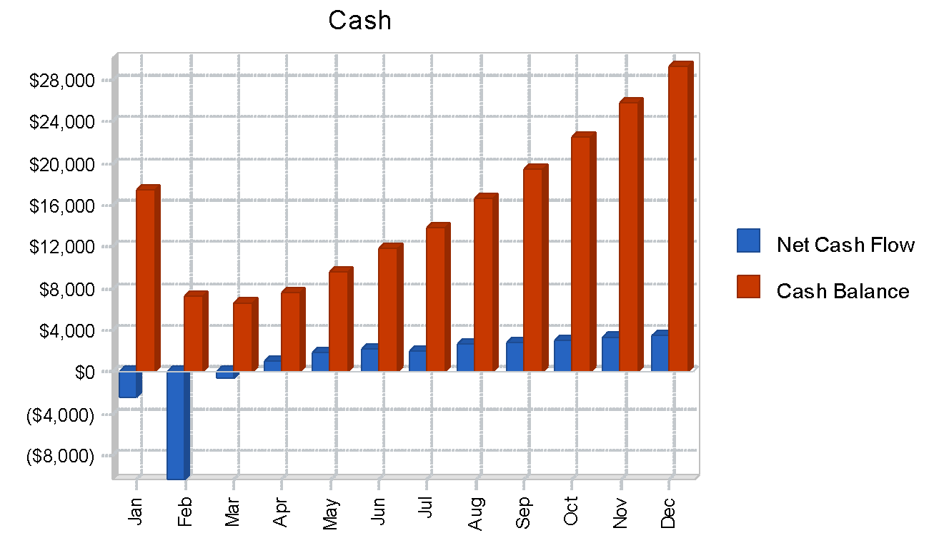

### Projected Balance Sheet

|  | **FY2024** | **FY2025** | **FY2026** |
| --- | --- | --- | --- |
| Pro Forma Balance Sheet |  |  |  |
|  | 2024 | 2025 | 2026 |
| Assets |  |  |  |
| Current Assets |  |  |  |
| Cash | $29,418 | $48,582 | 50,596 |
| Accounts Receivable | $10,730 | $14,560 | $20,680 |
| Other Current Assets | $5,000.00 | $5,000 | 5,000 |
| **Total Current Assets** | $45,148 | $68,142 | $76,276 |
|  |  |  |  |
| Long-term Assets |  |  |  |
| Long-term Assets | $0 | $0 | $0.00 |
| Accumulated Depreciation | $0 | $0 | $0.00 |
| Total Long-term Assets | $0 | $0 | $0 |
| **Total Assets** | $45,148 | $68,142 | $76,276 |
|  |  |  |  |
| Liabilities and Capital | 2024 | 2025 | 2026 |
| Current Liabilities |  |  |  |
| Accounts Payable | $10,708 | $12,418 | $18,663 |
| Current Borrowing | $0 | $0 | $0 |
| Other Current Liabilities | $0 | $0 | $0 |
| **Subtotal Current Liabilities** | **$10,708** | **$12,418** | **$18,663** |
|  |  |  |  |
| Long-term Liabilities | $0.00 | $0.00 | $0.00 |
| **Total Liabilities** | $10,708.00 | $12,418.00 | $18,663.00 |
|  |  |  |  |
| Paid-in Capital | $10,000 | $10,000 | $10,000 |
| Retained Earnings | $15,396 | $4,441 | -$14,276 |
| Earnings | $9,045 | $41,284 | $61,889 |
| Total Capital | $34,441 | $55,724 | $57,613 |
| **Total Liabilities and Capital** | $45,148 | $68,142 | $76,276 |
|  |  |  |  |
| **Net Worth** | $34,441 | $55,724 | $57,613 |

### Business Ratios

The Sorcerer's Accountant is compared here to the "Office Administrative Services" industry of under $500,000 in revenues. Comparison to the other closest industry, "Tax Preparation Services," is less useful because of the differences created by the new revenue line.

Sorcerer's Accounting does not hold substantial current or long-term assets, besides some office equipment and a rental security deposit. The assets of the business are primarily the human and knowledge assets of Max Greenwood, and the resources presented on the Sorcerer's Accounting website which are not recognized here. This explains the differences in asset ratios.

Gross margins will be higher than industry averages, as employees will be contracted directly to clients only for the bookkeeping services and not for the accounting services of the business. However, S G & A will be higher than the industry averages because of the need for an extra level of management to oversee the employees.

|  |  |  |  |  |
| --- | --- | --- | --- | --- |
| Ratio Analysis |  |  |  |  |
|  | 2025 | 2026 | 2027 | Industry Profile |
| Sales Growth | 24.63% | 35.69% | 42.03% | 3.34% |
|  |  |  |  |  |
| Percent of Total Assets |  |  |  |  |
| Accounts Receivable | 23.77% | 21.37% | 27.11% | 14.34% |
| Other Current Assets | 11.07% | 7.34% | 6.56% | 53.58% |
| Total Current Assets | 100.00% | 100.00% | 100.00% | 70.11% |
| Long-term Assets | 0.00% | 0.00% | 0.00% | 29.89% |
| **Total Assets** | 100.00% | 100.00% | 100.00% | 100.00% |
|  |  |  |  |  |
| Current Liabilities | 23.72% | 18.22% | 24.47% | 37.94% |
| Long-term Liabilities | 0.00% | 0.00% | 0.00% | 54.53% |
| **Total Liabilities** | 23.72% | 18.22% | 24.47% | 92.47% |
| **Net Worth** | 76.28% | 81.78% | 75.53% | 7.53% |
|  |  |  |  |  |
| Percent of Sales |  |  |  |  |
| Sales | 100.00% | 100.00% | 100.00% | 100.00% |
| Gross Margin | 86.23% | 77.82% | 70.32% | 59.56% |
| Selling, General & Administrative Expenses | 82.08% | 63.87% | 55.60% | 28.35% |
| Advertising Expenses | 17.65% | 6.76% | 4.76% | 1.21% |
| Profit Before Interest and Taxes | 5.92% | 19.93% | 21.03% | 8.19% |
|  |  |  |  |  |
| Main Ratios |  |  |  |  |
| Current | $4.22 | $5.49 | $4.09 | 1.24 |
| Quick | $4 | $5 | $4 | 1.18 |
| Total Debt to Total Assets | 23.72% | 18.22% | 24.47% | 92.47% |
| Pre-tax Return on Net Worth | 37.52% | 105.84% | 153.46% | 696.33% |
| Pre-tax Return on Assets | 28.62% | 86.55% | 115.91% | 52.41% |
|  |  |  |  |  |
| Additional Ratios | 2024 | 2025 | 2026 |  |
| Net Profit Margin | 4.15% | 13.95% | 14.72% | n.a |
| Return on Equity | 26.26% | 74.09% | 107.42% | n.a |
|  |  |  |  |  |
| Activity Ratios |  |  |  |  |
| Accounts Receivable Turnover | $10 | $10 | $10 | n.a |
| Collection Days | $29 | $31 | $31 | n.a |
| Accounts Payable Turnover | 10.78 | 12.17 | 12.17 | n.a |
| Payment Days | $29 | $28 | $25 | n.a |
| **Total Asset Turnover** | 4.83 | 4.34 | 5.51 | n.a |
|  |  |  |  |  |
| Debt Ratios |  |  |  |  |
| Debt to Net Worth | $0 | $0 | $0 | n.a |
| Current Liab. to Liab. | 1 | 1 | 1 | n.a |
|  |  |  |  |  |
| Liquidity Ratios |  |  |  |  |
| Net Working Capital | $34,441 | $55,724 | $57,613 | n.a |
| Interest Coverage | 0 | 0 | 0 | n.a |
|  |  |  |  |  |
| Additional Ratios |  |  |  |  |
| Assets to Sales | 0.21 | 0.23 | 0.18 | n.a |
| Current Debt/Total Assets | 24% | 18% | 24% | n.a |
| Acid Test | 3.21 | 4.31 | 2.98 | n.a |
| Sales/Net Worth | 6.33 | 5.31 | 7.3 | n.a |
| Dividend Payout | 0 | 0.48 | 0.97 | n.a |

[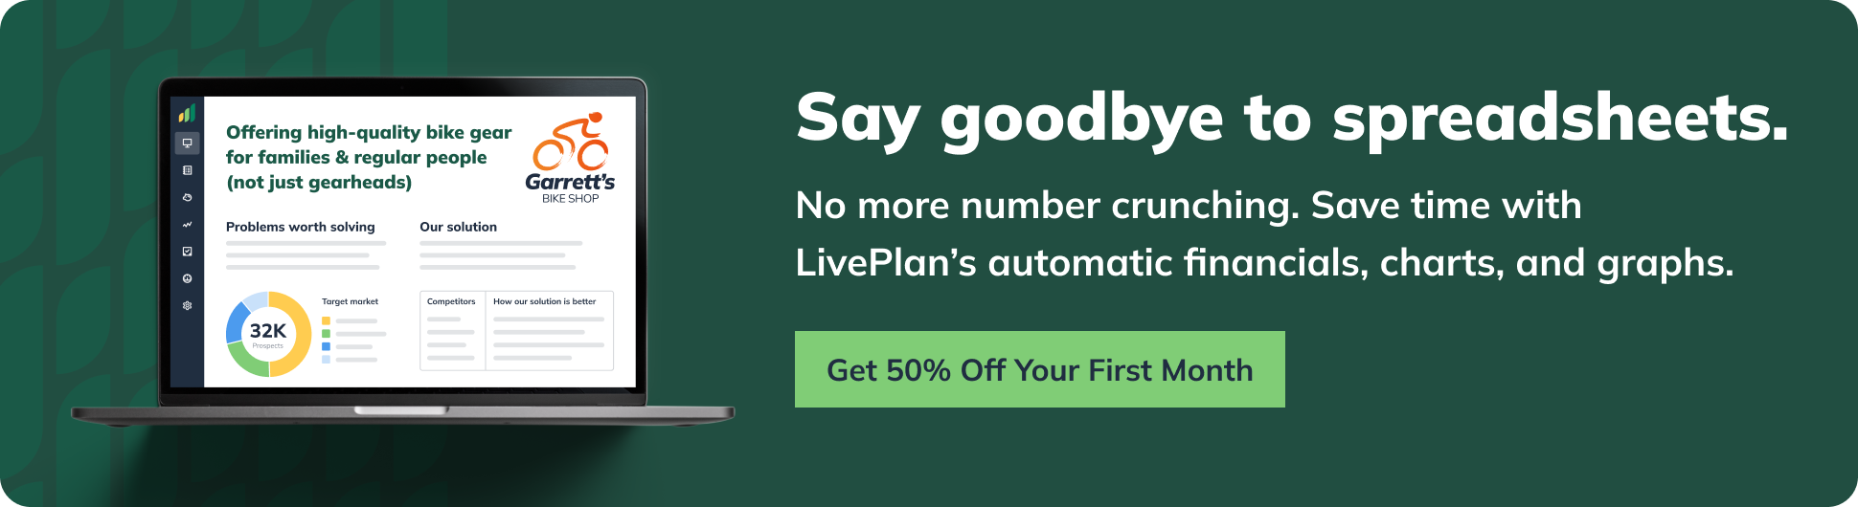](https://www.liveplan.com/pricing?offer=BUS_SAMPLE_HALFOFF&utm_source=Liveplan&utm_medium=Download&utm_campaign=Sample_plan&utm_content=accounting_and_bookkeeping)

# Appendix

**⭐️Pro tip:** You can crunch these numbers yourself in spreadsheets, but [LivePlan](https://www.liveplan.com/pricing?offer=BUS_SAMPLE_HALFOFF&utm_source=liveplan&utm_medium=download&utm_campaign=sample_plan&utm_content=accounting_and_bookeeping) makes calculating your numbers much easier with **automatic financials, charts, and graphs**.

Table: Sales Forecast

| **FY2024** |  | **Jan** | **Feb** | **Mar** | **Apr** | **May** | **Jun** | **Jul** | **Aug** | **Sep** | **Oct** | **Nov** | **Dec** |
| --- | --- | --- | --- | --- | --- | --- | --- | --- | --- | --- | --- | --- | --- |
| **Unit Sales** |  |  |  |  |  |  |  |  |  |  |  |  |  |
| Tax Preparations |  | $8 | $10 | 11 | 16 | $10 | 10 | $10 | 10 | 10 | 10 | 10 | 10 |
| Cost Accounting Analysis |  | $5 | 4 | 2 | 2 | 6 | 6 | 6 | 6 | 6 | 6 | 6 | 6 |
| QuickBooks Services |  | 4 | 4 | 4 | 5 | $5 | 5 | $5 | 5 | 5 | 5 | 5 | 5 |
| Bookkeeping Hours |  | 0 | 50 | 70 | 90 | $100 | 120 | $140 | 160 | 180 | 200 | 220 | 240 |
| Total Unit Sales |  | 17 | 67 | 88 | 113 | 121 | 141 | 161 | 181 | 201 | 221 | 241 | 261 |
|  |  |  |  |  |  |  |  |  |  |  |  |  |  |
| **Unit Prices** |  | Jan | Feb | Mar | Apr | May | Jun | Jul | Aug | Sep | Oct | Nov | Dec |
| Tax Preparations |  | $750 | $750.00 | $750.00 | $750.00 | $750.00 | $750.00 | $750.00 | $750.00 | $750.00 | $750.00 | $750.00 | $750.00 |
| Cost Accounting Analysis |  | $1,000.00 | $1,000.00 | $1,000.00 | $1,000.00 | $1,000.00 | $1,000.00 | $1,000.00 | $1,000.00 | $1,000.00 | $1,000.00 | $1,000.00 | $1,000.00 |
| QuickBooks Services |  | $300.00 | $300.00 | $300.00 | $300.00 | $300 | $300 | $300 | $300.00 | $300.00 | $300.00 | $300.00 | $300.00 |
| Bookkeeping Hours |  | $30.00 | $30.00 | $30.00 | $30.00 | $30 | $30 | $30 | $30.00 | $30.00 | $30.00 | $30.00 | $30.00 |
|  |  |  |  |  |  |  |  |  |  |  |  |  |  |
| **Sales** |  |  |  |  |  |  |  |  |  |  |  |  |  |
| Tax Preparations |  | $6,000 | $7,200 | $8,400 | $12,000 | $7,500 | $7,500 | $7,500 | $7,500 | $7,500 | $7,500 | $7,500 | $7,500 |
| Cost Accounting Analysis |  | $4,800 | $3,600 | $2,400 | $1,500 | $6,000 | $6,000 | $6,000 | $6,000 | $6,000 | $6,000 | $6,000 | $6,000 |
| QuickBooks Services |  | $1,200 | $1,200 | $1,200 | $1,500 | $1,500 | $1,500 | $1,500 | $1,500 | $1,500 | $1,500 | $1,500 | $1,500 |
| Bookkeeping Hours |  | $0 | $1,500 | $2,100 | $2,700 | $3,000 | $3,600 | $4,200 | $4,800 | $5,400 | $6,000 | $6,600 | $7,200 |
| Total Sales |  | $12,000 | $13,500 | $14,100 | $17,700 | $18,000 | $18,600 | $19,200 | $19,800 | $20,400 | $21,000 | $21,600 | $22,200 |
|  |  |  |  |  |  |  |  |  |  |  |  |  |  |
| **Direct Unit Costs** |  | Jan | Feb | Mar | Apr | May | Jun | Jul | Aug | Sep | Oct | Nov | Dec |
| Tax Preparations | 5.00% | $37.50 | $37.50 | $37.50 | $37.50 | $38 | $38 | $38 | $37.50 | $37.50 | $37.50 | $37.50 | $37.50 |
| Cost Accounting Analysis | 3.00% | $30.00 | $30.00 | $30.00 | $30.00 | $30 | $30.00 | $30 | $30.00 | $30.00 | $30.00 | $30.00 | $30.00 |
| QuickBooks Services | 0.00% | $0 | $0 | $0.00 | $0.00 | 0 | $0.00 | $0.00 | $0.00 | $0.00 | $0.00 | $0.00 | $0.00 |
| Bookkeeping Hours | 50.00% | $15.00 | $15.00 | $15.00 | $15.00 | $15 | $15.00 | $15 | $15.00 | $15.00 | $15.00 | $15.00 | $15.00 |
| **Direct Cost of Sales** |  |  |  |  |  |  |  |  |  |  |  |  |  |
| Tax Preparations |  | $300 | $360 | $420 | $600 | $375 | $375 | $375 | $375 | $375 | $375 | $375 | $375 |
| Cost Accounting Analysis |  | $144 | $108 | $72 | $45 | $180 | $180 | $180 | $180 | $180 | $180 | $180 | $180 |
| QuickBooks Services |  | $0 | $0 | $0 | $0 | $0 | $0 | $0 | $0 | $0 | $0 | $0 | $0 |
| Bookkeeping Hours |  | $0 | $750 | $1,050 | $1,350 | $1,500 | $1,800 | $2,100 | $2,400 | $2,700 | $3,000 | $3,300 | $3,600 |
| **Subtotal Direct Cost of Sales** |  | $444 | $1,218 | $1,542 | $1,995 | $2,055 | $2,355 | $2,655 | $2,955 | $3,255 | $3,555 | $3,855 | $4,155 |

Table: Personnel

| **FY2023** | **Mar** | **Jan** | **Feb** | **Mar** | **Apr** | **May** | **Jun** | **Jul** | **Aug** | **Sep** | **Oct** | **Nov** | **Dec** |
| --- | --- | --- | --- | --- | --- | --- | --- | --- | --- | --- | --- | --- | --- |
| Bookkeeper training-period wages |  | $800 | $0 | $0 | $0 | $0 | $0 | $400 | $0 | $0 | $0 | $0 | $0 |
| Max Greenwood |  | $5,000 | $5,000 | 5,000 | 5,000 | $5,000 | $5,000 | $5,000 | $5,000 | $5,000 | $5,000 | $5,000 | $5,000 |
| Bookkeeper Manager |  | $2,000 | 2,000 | 2,000 | 2,000 | 2,000 | $2,000 | $2,000 | $2,000 | $2,000 | $2,000 | $2,000 | $2,000 |
| Benefits | 10.00% | $700 | $700 | $700 | 700 | $700 | $700 | $700 | $700 | $700 | $700 | $700 | $700 |
| Total People |  | 4 | 4 | 4 | 4 | $4 | 4 | $5 | 5 | 5 | 5 | 5 | 5 |
|  |  |  |  |  |  |  |  |  |  |  |  |  |  |
| **Total Payroll** |  | $8,500 | $7,700 | $7,700 | $7,700 | $7,700 | $7,700 | $8,100 | $7,700 | $7,700 | $7,700 | $7,700 | $7,700 |

Table: Profit and Loss

| **FY2023** |  | **Jan** | **Feb** | **Mar** | **Apr** | **May** | **Jun** | **Jul** | **Aug** | **Sep** | **Oct** | **Nov** | **Dec** |
| --- | --- | --- | --- | --- | --- | --- | --- | --- | --- | --- | --- | --- | --- |
| *Pro Forma Profit and Loss* |  |  |  |  |  |  |  |  |  |  |  |  |  |
| Sales |  | $12,000 | 13,500 | 14,100 | 17,700 | 18,000 | $18,600 | $19,200 | $19,800 | $20,400 | $21,000 | $21,600 | $22,200 |
| Direct Cost of Sales |  | $444 | $1,218 | $1,542 | 1,995 | $2,055 | $2,355 | $2,655 | $2,955 | $3,255 | $3,555 | $3,855 | $4,155 |
| Other Cost of Sales |  | $0 | $0 | $0 | 0 | $0 | $0 | $0 | $0 | $0 | $0 | $0 | $0 |
| **Total Cost of Sales** |  | $444 | $1,218 | $1,542 | $1,995 | $2,055 | $2,355 | $2,655 | $2,955 | $3,255 | $3,555 | $3,855 | $4,155 |
|  |  |  |  |  |  |  |  |  |  |  |  |  |  |
| Gross Margin |  | $11,556 | $12,282 | $12,558 | $15,705 | $15,945 | $16,245 | $16,545 | $16,845 | $17,145 | $17,445 | $17,745 | $18,045 |
| Gross Margin % |  | 96.30% | 90.98% | 89.06% | 88.73% | 88.58% | 87.34% | 86.17% | 85.08% | 84.04% | 83.07% | 82.15% | 81.28% |
|  |  |  |  |  |  |  |  |  |  |  |  |  |  |
|  |  |  |  |  |  |  |  |  |  |  |  |  |  |
| **Expenses** |  |  |  |  |  |  |  |  |  |  |  |  |  |
| Payroll |  | $8,500 | $7,700 | $7,700 | $7,700 | $7,700 | $7,700 | $8,100 | $7,700 | $7,700 | $7,700 | $7,700 | $7,700 |
| Marketing/Promotion |  | $10,000 | $3,000 | $3,000 | $2,500 | $2,500 | $2,500 | $2,500 | $2,500 | $2,500 | $2,500 | $2,500 | $2,500 |
| Depreciation |  | $0 | $0 | $0 | $0 | $0 | $0 | $0 | $0 | $0 | $0 | $0 | $0 |
| Rent |  | $1,500 | $1,500 | $1,500 | $1,500 | $1,500 | $1,500 | $1,500 | $1,500 | $1,500 | $1,500 | $1,500 | $1,500 |
| Utilities |  | $200 | $200 | $200 | $200 | $200 | $200 | $200 | $200 | $200 | $200 | $200 | $200 |
| Insurance |  | $5,000 | $0 | $0 | $0 | $0 | $0 | $0 | $0 | $0 | $0 | $0 | $0 |
| Payroll Taxes | 15.00% | $1,275 | $1,155 | $1,155 | $1,155 | $1,155 | $1,155 | $1,215 | $1,155 | $1,155 | $1,155 | $1,155 | $1,155 |
| Software and Computer Expenses |  | $2,500 | $100 | $100 | $100 | $100 | $100 | $100 | $100 | $100 | $100 | $100 | $100 |
|  |  |  |  |  |  |  |  |  |  |  |  |  |  |
| **Total Operating Expenses** |  | $28,975.00 | $13,655.00 | $13,655.00 | $13,155.00 | $13,155 | $13,155 | $13,615 | $13,155.00 | $13,155.00 | $13,155.00 | $13,155.00 | $13,155.00 |
|  |  |  |  |  |  |  |  |  |  |  |  |  |  |
| Profit Before Interest and Taxes |  | -$17,419 | -$1,373 | -$1,097.00 | $2,550.00 | 2,790 | $3,090.00 | $2,930.00 | $3,690.00 | $3,990.00 | $4,290.00 | $4,590.00 | $4,890.00 |
| EBITDA |  | -$17,419.00 | -$1,373.00 | -$1,097.00 | $2,550.00 | $2,790 | $3,090.00 | $2,930 | $3,690.00 | $3,990.00 | $4,290.00 | $4,590.00 | $4,890.00 |
| Interest Expense |  | $0 | $0 | $0 | $0 | $0 | $0 | $0 | $0 | $0 | $0 | $0 | $0 |
| Taxes Incurred |  | -$5,226 | -$412 | -$329 | $765 | $837 | $927 | $879 | $1,107 | $1,197 | $1,287 | $1,377 | $1,467 |
|  |  |  |  |  |  |  |  |  |  |  |  |  |  |
| Net Profit |  | -$12,193 | -$961 | -$768 | $1,785 | $1,953 | $2,163 | $2,051 | $2,583 | $2,793 | $3,003 | $3,213 | $3,423 |
| **Net Profit/Sales** |  | -101.61% | -7.12% | -5.45% | 10.08% | 10.85% | 11.63% | 10.68% | 13.05% | 13.69% | 14.30% | 14.88% | 15.42% |

Table: Cash Flow

| ***Pro Forma Cash Flow*** | **Jan** | **Feb** | **Mar** | **Apr** | **May** | **Jun** | **Jul** | **Aug** | **Sep** | **Oct** | **Nov** | **Dec** |
| --- | --- | --- | --- | --- | --- | --- | --- | --- | --- | --- | --- | --- |
| Cash Received |  |  |  |  |  |  |  |  |  |  |  |  |
| Cash from Operations |  |  |  |  |  |  |  |  |  |  |  |  |
| Cash Sales | $6,000 | $6,750 | $7,050 | 8,850 | $9,000 | $9,300 | $9,600 | $9,900 | $10,200 | $10,500 | $10,800 | $11,100 |
| Cash from Receivables | $7,492 | $6,025 | $6,760 | $7,110 | $8,855 | $9,010 | $9,310 | $9,610 | $9,910 | $10,210 | $10,510 | $10,810 |
| **Subtotal Cash from Operations** | $13,492 | $12,775 | $13,810 | $15,960 | $17,855 | $18,310 | $18,910 | $19,510 | $20,110 | $20,710 | $21,310 | $21,910 |
|  |  |  |  |  |  |  |  |  |  |  |  |  |
| Additional Cash Received |  |  |  |  |  |  |  |  |  |  |  |  |
| Sales Tax, VAT, HST/GST Received | $0.00 | $0.00 | $0.00 | $0.00 | $0.00 | $0.00 | $0.00 | $0.00 | $0.00 | $0.00 | $0.00 | $0.00 |
| New Current Borrowing | $0.00 | $0.00 | $0.00 | $0.00 | $0 | $0 | $0 | $0.00 | $0.00 | $0.00 | $0.00 | $0.00 |
| New Other Liabilities (interest-free) | $0.00 | $0.00 | $0.00 | $0.00 | $0 | $0 | $0 | $0.00 | $0.00 | $0.00 | $0.00 | $0.00 |
| New Long-term Liabilities | $0 | $0 | $0 | $0 | $0 | $0 | $0 | $0 | $0 | $0 | $0 | $0 |
| Sales of Other Current Assets | $0 | $0 | $0 | $0 | $0 | $0 | $0 | $0 | $0 | $0 | $0 | $0 |
| Sales of Long-term Assets | $0 | $0 | $0 | $0 | $0 | $0 | $0 | $0 | $0 | $0 | $0 | $0 |
| New Investment Received | $0 | $0 | $0 | $0 | $0 | $0 | $0 | $0 | $0 | $0 | $0 | $0 |
| **Subtotal Cash Received** | $13,492 | $12,775 | $13,810 | $15,960 | $17,855 | $18,310 | $18,910 | $19,510 | $20,110 | $20,710 | $21,310 | $21,910 |
|  |  |  |  |  |  |  |  |  |  |  |  |  |
| **Expenditures** | Jan | Feb | Mar | Apr | May | Jun | Jul | Aug | Sep | Oct | Nov | Dec |
| Expenditures from Operations |  |  |  |  |  |  |  |  |  |  |  |  |
| Cash Spending | $8,500.00 | $7,700.00 | $7,700.00 | $7,700.00 | $7,700 | $7,700 | $8,100 | $7,700.00 | $7,700.00 | $7,700.00 | $7,700.00 | $7,700.00 |
| Bill Payments | $7,419.00 | $15,396.00 | $6,775.00 | $7,203.00 | $8,219 | $8,360.00 | $8,747 | $9,065.00 | $9,530.00 | $9,920.00 | $10,310.00 | $10,700.00 |
| Subtotal Spent on Operations | $15,919 | $23,096 | $14,475.00 | $14,903.00 | 15,919 | $16,060.00 | $16,847.00 | $16,765.00 | $17,230.00 | $17,620.00 | $18,010.00 | $18,400.00 |
| **Additional Cash Spent** |  |  |  |  |  |  |  |  |  |  |  |  |
| Sales Tax, VAT, HST/GST Paid Out | $0 | $0 | $0 | $0 | $0 | $0 | $0 | $0 | $0 | $0 | $0 | $0 |
| Principal Repayment of Current Borrowing | $0 | $0 | $0 | $0 | $0 | $0 | $0 | $0 | $0 | $0 | $0 | $0 |
| Other Liabilities Principal Repayment | $0 | $0 | $0 | $0 | $0 | $0 | $0 | $0 | $0 | $0 | $0 | $0 |
| Long-term Liabilities Principal Repayment | $0 | $0 | $0 | $0 | $0 | $0 | $0 | $0 | $0 | $0 | $0 | $0 |
| Purchase Other Current Assets | $0 | $0 | $0 | $0 | $0 | $0 | $0 | $0 | $0 | $0 | $0 | $0 |
| Purchase Long-term Assets | $0 | $0 | $0 | $0 | $0 | $0 | $0 | $0 | $0 | $0 | $0 | $0 |
| Dividends | $0 | $0 | $0 | $0 | $0 | $0 | $0 | $0 | $0 | $0 | $0 | $0 |
| **Subtotal Cash Spent** | $15,919 | $23,096 | $14,475 | $14,903 | $15,919 | $16,060 | $16,847 | $16,765 | $17,230 | $17,620 | $18,010 | $18,400 |
|  |  |  |  |  |  |  |  |  |  |  |  |  |
| Net Cash Flow | -$2,427 | -$10,321 | -$665 | $1,057 | $1,936 | $2,250 | $2,063 | $2,745 | $2,880 | $3,090 | $3,300 | $3,510 |
| **Cash Balance** | $17,573 | $7,252 | $6,588 | $7,645 | $9,580 | $11,830 | $13,893 | $16,638 | $19,518 | $22,608 | $25,908 | $29,418 |

Table: Balance Sheet

| **FY2023** |  | **Jan** | **Feb** | **Mar** | **Apr** | **May** | **Jun** | **Jul** | **Aug** | **Sep** | **Oct** | **Nov** | **Dec** |
| --- | --- | --- | --- | --- | --- | --- | --- | --- | --- | --- | --- | --- | --- |
| ***Pro Forma Balance Sheet*** |  |  |  |  |  |  |  |  |  |  |  |  |  |
| Assets |  |  |  |  |  |  |  |  |  |  |  |  |  |
| Current Assets |  |  |  |  |  |  |  |  |  |  |  |  |  |
| Cash | $20,000 | $17,573 | $7,252 | $6,588 | 7,645 | $9,580 | $11,830 | $13,893 | $16,638 | $19,518 | $22,608 | $25,908 | $29,418 |
| Accounts Receivable | $7,292 | $5,800 | $6,525 | $6,815 | $8,555 | $8,700 | $8,990 | $9,280 | $9,570 | $9,860 | $10,150 | $10,440 | $10,730 |
| Other Current Assets | $5,000 | $5,000 | $5,000 | $5,000 | $5,000 | $5,000 | $5,000 | $5,000 | $5,000 | $5,000 | $5,000 | $5,000 | $5,000 |
| **Total Current Assets** | $32,292 | $28,373 | $18,777 | $18,403 | $21,200 | $23,280 | $25,820 | $28,173 | $31,208 | $34,378 | $37,758 | $41,348 | $45,148 |
| Long-term Assets |  |  |  |  |  |  |  |  |  |  |  |  |  |
| Long-term Assets | $0 | $0.00 | $0.00 | $0.00 | $0.00 | $0 | $0 | $0 | $0.00 | $0.00 | $0.00 | $0.00 | $0.00 |
| Accumulated Depreciation | $0 | $0.00 | $0.00 | $0.00 | $0.00 | $0 | $0 | $0 | $0.00 | $0.00 | $0.00 | $0.00 | $0.00 |
| Total Long-term Assets | $0 | $0 | $0 | $0 | $0 | $0 | $0 | $0 | $0 | $0 | $0 | $0 | $0 |
| **Total Assets** | $32,292 | $28,373 | $18,777 | $18,403 | $21,200 | $23,280 | $25,820 | $28,173 | $31,208 | $34,378 | $37,758 | $41,348 | $45,148 |
|  |  |  |  |  |  |  |  |  |  |  |  |  |  |
| **Liabilities and Capital** |  | Jan | Feb | Mar | Apr | May | Jun | Jul | Aug | Sep | Oct | Nov | Dec |
|  |  |  |  |  |  |  |  |  |  |  |  |  |  |
| **Current Liabilities** |  |  |  |  |  |  |  |  |  |  |  |  |  |
| Accounts Payable | $6,896 | $15,170 | $6,536 | $6,929 | $7,941 | $8,069 | $8,446 | $8,747 | $9,200 | $9,577 | $9,954 | $10,331 | $10,708 |
| Current Borrowing | $0 | $0 | $0 | $0 | $0 | $0 | $0 | $0 | $0 | $0 | $0 | $0 | $0 |
| Other Current Liabilities | $0 | $0 | $0 | $0 | $0 | $0 | $0 | $0 | $0 | $0 | $0 | $0 | $0 |
| **Subtotal Current Liabilities** | $6,896 | $15,170.00 | $6,536.00 | $6,929.00 | $7,941.00 | $8,069 | $8,446 | $8,747 | $9,200.00 | $9,577.00 | $9,954.00 | $10,331.00 | $10,708.00 |
|  |  |  |  |  |  |  |  |  |  |  |  |  |  |
| **Long-term Liabilities** | $0 | $0 | $0 | $0.00 | $0.00 | 0 | $0.00 | $0.00 | $0.00 | $0.00 | $0.00 | $0.00 | $0.00 |
| **Total Liabilities** | $6,896 | $15,170.00 | $6,536.00 | $6,929.00 | $7,941.00 | $8,069 | $8,446.00 | $8,747 | $9,200.00 | $9,577.00 | $9,954.00 | $10,331.00 | $10,708.00 |
|  |  |  |  |  |  |  |  |  |  |  |  |  |  |
| Paid-in Capital | $10,000 | $10,000 | $10,000 | $10,000 | $10,000 | $10,000 | $10,000 | $10,000 | $10,000 | $10,000 | $10,000 | $10,000 | $10,000 |
| Retained Earnings | -$83,554 | $15,396 | $15,396 | $15,396 | $15,396 | $15,396 | $15,396 | $15,396 | $15,396 | $15,396 | $15,396 | $15,396 | $15,396 |
| Earnings | $98,950 | -$12,193 | -$13,154 | -$13,922 | -$12,137 | -$10,184 | -$8,021 | -$5,970 | -$3,387 | -$594 | $2,409 | $5,622 | $9,045 |
| Total Capital | $25,396 | $13,203 | $12,241 | $11,474 | $13,259 | $15,212 | $17,375 | $19,426 | $22,009 | $24,802 | $27,805 | $31,018 | $34,441 |
| **Total Liabilities and Capital** | $32,292 | $28,373 | $18,777 | $18,403 | $21,200 | $23,280 | $25,820 | $28,173 | $31,208 | $34,378 | $37,758 | $41,348 | $45,148 |
| **Net Worth** | $25,396 | $13,203 | $12,241 | $11,474 | $13,259 | $15,212 | $17,375 | $19,426 | $22,009 | $24,802 | $27,805 | $31,018 | $34,441 |

Next Steps:  
**⭐️Pro Tip:** If you haven’t already done so - be sure to go back and finish the Executive Summary (which we recommended you save for last).

Applying for funding?

You’ll want to be sure your pitch and finished plan are well thought through and accurate. LivePlan’s step-by-step guidance, automated financials, and visual charts and graphs will help you write a business plan that'll maximize your chances of securing funding in a format lenders and investors will expect to see. [**Learn more**](https://www.liveplan.com/secure-funding/?offer=BUS_SAMPLE_HALFOFF&utm_source=Liveplan&utm_medium=Download&utm_campaign=Sample_plan&utm_content=accounting_and_bookkeeping)

Validating a business idea?

You likely don’t have any historical data yet, so you’ll want to be sure you’ve put some serious thought into all the factors going into your plan and forecast. Ensure that you’ve thoroughly thought through your target market and the problem you’re solving as well as your business model and financials. LivePlan will help you forecast your revenue to see if your idea is financially sound and provide competitor benchmarks for the ultimate reality check. [**Learn more**](https://www.liveplan.com/the-growth-planning-process-for-ideas?offer=BUS_SAMPLE_HALFOFF&utm_source=Liveplan&utm_medium=Download&utm_campaign=Sample_plan&utm_content=accounting_and_bookkeeping)

Growing your business?

You’ll want to compare your forecast to your actual business performance (plan vs. actuals). Doing so will help you spot where your forecast was accurate (or off) and determine opportunities for growth. LivePlan's Dashboard easily connects with Quickbooks or Xero to give you a detailed look at how your revenue measures up to projections, so you can make informed business decisions. [**Learn more**](https://www.liveplan.com/the-growth-planning-process-for-established-businesses?offer=BUS_SAMPLE_HALFOFF&utm_source=Liveplan&utm_medium=Download&utm_campaign=Sample_plan&utm_content=accounting_and_bookkeeping)

[](https://www.liveplan.com/pricing?offer=BUS_SAMPLE_HALFOFF&utm_source=Liveplan&utm_medium=Download&utm_campaign=Sample_plan&utm_content=accounting_and_bookkeeping)